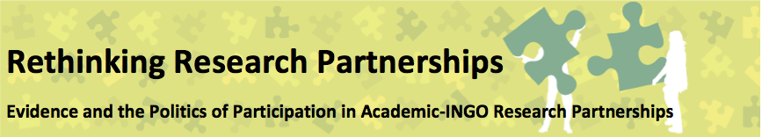
Workshop 3: Designing research: 20th October 2015
These are brief notes on the discussion of the day aiming to capture the nature of the discussion, reflections and insights, rather than giving a detailed account of the day.
Reflections from the case studies
Learnings from a funded research partnership
- In developing a narrative around the research partnerships it is noteworthy that while the partnerships included multiple actors in the global south, the way we discuss these partnerships often only includes voices from the global north. As the series continues we need to consider more ways of bringing in different perspectives into the discussion, to ensure that our own analysis does not contribute to a specific narrative developing.
- Within any partnership there will be different spaces of interaction, each of which provide their own opportunities and/or constraints. It is important to understand the different nature of these different spaces (for example an international conference which brought actors together outside of the normal project space and provided a more neutral ground for discussion and development of shared perspectives).
- The challenge of ‘retrofitting’ research – research can be a practical bridge – between programme intervention and influencing/advocacy aims of a programme. But if the research is not well integrated or retrofitted this limits the ability to be used/useful in the programme, and can lead to tensions in implementation. Designing a programme of work which includes a research element can be very different from designing a programme of implementation – different things need to be considered to make the programme make sense.
- International/development research can include a v. long chain of people. In one case study participants included: UK academics, UK NGO; national /country office of NGO; implementing partner organisations; national research body; and the institutional funder - all the different actors had different agendas and timetables , made it difficult to have in-depth conversation about the concepts themselves that were being researched (e.g. how are gender relations being conceptualised) which leads to further tensions: ‘You are being imperialist’ ‘No, you are being patriachal’. The dynamics between a local partner organisation and national university professor are also complex. Also within a funded project when there are a range of deliverables conversations often focus on project (and crisis) management, rather than the nature of the findings. It is important to create space for discussion on the research findings themselves – and to develop concepts/deepen understanding/exchange views together so that there is collaborative ownership of the research agenda
- The pressures on the research can be exacerbated by (a donor) desire for a ‘simple story’ – to find a magic bullet which would ‘solve’ the problem being researched – this is very different from the exploratory nature of research as it was conceptualised by the NGO and academics who wanted to explore complexity, and valued contextualised findings
- Researchers in universities in the global south are often operating in highly pressurised environments with no actual funding for research, and all the emphasis on teaching and learning – so the participants in this research saw it as a private consultancy opportunity – to generate additional income, rather than integrating the research into a national research agenda/to influence policy development nationally. It is not always academic institutions that are the most appropriate research partners, it can be other NGOs. It is important to think through what the expectations of research partners are – is it because of status and influence over national policy, or expertise in methodology – these can lead you in very different directions.
- It can be difficult to integrate learning from a research project into NGO practice – often funded projects are managed quite separately from day to day practice in an NGO so how to make sure the learning flows. This can also be the case at national level for example Local NGOs had huge deference for university professors but also rejected the research findings – they felt they knew the reality of what happened on the ground better than the professors and carried on with activities that were inconsistent with the research findings despite this deference.
- The first part of a research partnership – i.e. when you are trying to agree the scope, define the conceptual framework, understand the baseline etc. is really important and needs time and money, but donors will not often fund this phase. Equally there are various important but invisible parts of partnership (e.g. relationship building and space for conversation) that need money. It could be worth developing partnerships at country level before a funding opportunity presents, and then bidding for the opportunity together – rather than securing funding and then looking for a partner. This is particularly important for co-creation of research – otherwise there is a danger that southern partners just become data collectors.
Learnings from an emergent/ iterative partnership
- This partnership was a long-term collaboration, with a research component. Where and how connections were made in the collaboration could be explained with the image of a high-rise building, with lifts going up and down the building. Different motivations lead different actors to get off the lift on different floors in the building – and the lifts may move up and down the different floors at different points during the project. For example, the UK based NGO wanted to maintain a good relationship with the donor and wanted to translate an abstract concept into a practical reality – using the current development discourse/language – whereas locally the language was very different – and staff wanted to understand actual impact. The country office wanted to learn, but also felt that having an evaluation carried out by an academic partner would give them kudos, which could be useful for advocacy, the university was influenced by the research excellence framework – which meant it needed to deliver outputs and publications.
- The university developed a ToR and asked for feedback – they had expected an intense negotiation process, but everyone said fine, carry on. It was useless to send out a ToR for comment – so strategies had to be developed to overcome this.
- However, it was clear that people engaged more actively in the actual practice, as it emerged – with intense discussions on the ground – so collaboration happened through action rather than in relation to a document. There was also the role of the NGO in translating the academic reports, so that they could be accessed – this was particularly the case at national level, where the national lead played a key role in reaching different audiences – how this person introduced the research to local partners influenced the research design – during the process of the research itself, rather than through discussions of a document.
- The collaboration happened at different times in different ways in different spaces, but there was no overall coming together – this was a missed opportunity. It was clear that different institutions want to deal with different levels of complexity – the academic versus the practical/pragmatic – for example the NGO was trying to bring about change by working within existing structural dynamics, while the academic was concerned that this work reinforced structural inequalities – the partnership meant that the NGO was challenged to engage with structural change processes, while the university was challenged to be more pragmatic.
- Trust was really important in the process (and took a long time to build) –as design was happening through the relationships throughout the partnership – there were open spaces for shaping the design, but this was only possible because there was trust – to listen, reflect and imaging – this meant that the design phase was interactive, extended and horizontal – and hard to capture. It can also be hard to maintain trust when there is turnover of staff.
- In terms of outputs, what is useful for local actors may not be academically useful. Equally, academic reflections are conceptually unwieldy and don’t lend themselves naturally to translation for communities on the ground, need to add an internal process with the NGO to make the findings work within the context of internal dynamics/incentives in the NGO. The university found it hard to meet their responsibility to local communities to produce something useful. It’s important to build in the potential for redesign in the light of these conversations but this isn’t always possible, depending on the funder.
- SPACE, TIME, PROCESS, TRANSLATION – all critical for partnership to go well (or not).
- Norms and values shape our work; these are different between academia and NGOs and within each institution. There are lots of ways that individuals resist, challenge and undermine power in an everyday way, e.g. in everything we do and say we either collude with a dominant narrative or resist it. Making space and time for open, collaborative discussion allows us to challenge these narratives and for alternatives to emerge. Cultural processes of listening, informal discussion seem like a good start – how else can we make spaces that allow us to challenge dominant power?
- Power is very subtle e.g. signalling access to funding and viable practical projects – but these projects are often versions of the same kind of policy frameworks that have perpetuated injustice in the first place. Power can prevent us having the kind of conversations that will allow us to understand each other and build alternatives by imposing time pressures, pressures to deliver, etc. We need to recognise that the process of research design is not a rational linear process, but shaped by various different motivations, and happening through interactions in different spaces at different times.
Group Discussions (focused on Artefacts, Institutions and Practices)
In the afternoon we split into three groups to consider the three elements of our framework (institutions, artefacts and practices); each group worked to address a central question, and drew on the case studies shared in the morning as well as their own experiences and practices:
Artefacts: - What research tools are valued in the research and what impact does this have in terms of the types of evidence produced and the dynamics of participation within the partnership?
The group used a timeline to map out different artefacts within a research process, thinking through different types of ‘artefacts’ and how these interact with different stages in the research process. An extract of the timeline can be seen below: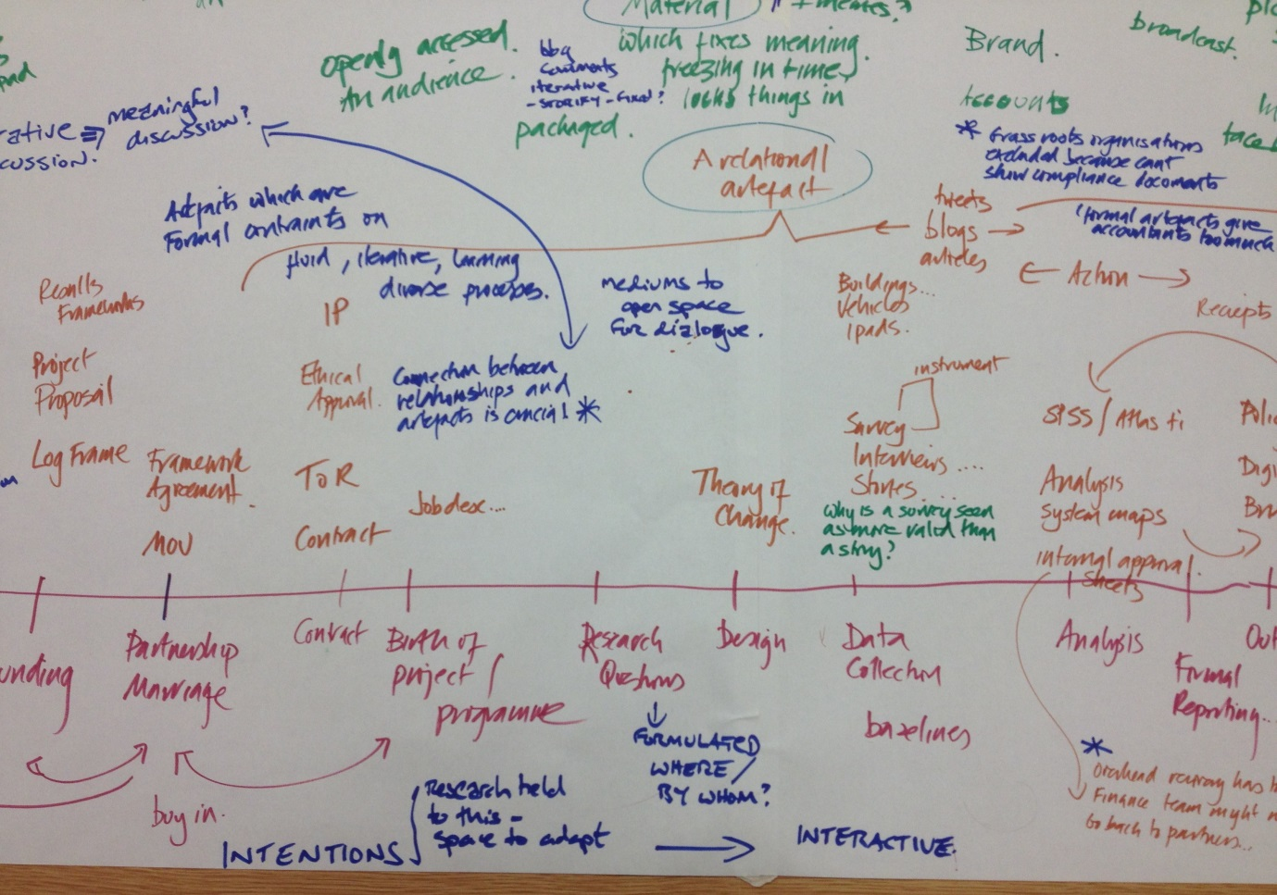
Reflections included: a recognition that artefacts are ‘a meaningful product of human labour and culture’ they are created rather than a necessary truth, but we often privilege (and monetise) a particular sort of artefact based on a western conception of knowledge – a story written over a story told?
When something is published it becomes formal – frozen in time – the material impacts the nature of the artefact – whether it is seen as a truth in itself, or something that is creative, iterative and recreated (i.e. the difference between a report and a blog – which can be interacted with, enable discussion and change overtime). Because of this it is important to consider which artefacts are disposed to being dialogical – i.e. creating space for talking and negotiation, and can aid in relationship building and co-creation of knowledge.
We often call things a partnership when we start working together, but actually it is the process of working together which creates a partnership – we talk about a partnership as if it is a thing, which can be owned, but a process is much harder to own – so what should the balance between an artefact and a process be – how does a partnership enable iteration – with different aretefacts feeding into different timelines in different ways?
It is movements that challenge hegemonic discourse – not the evidence itself – but we need to understand the place of evidence in the movement. Artefacts can also be used to create space – and bridge divides (for example using a map to enable non-personal discussion to take place so that people can interact in different ways).
Institutions (motivations and pressures, infrastructure and timeframes)
The group started by reflecting on the context of universities and NGOs, noting that universities are not set up as development agencies – there are some centre within them, but the university itself is not a development agency, whereas NGOs are. So what is the role of the NGO – is it as a convenor, a broker? To bring people together to further development agendas? Do NGOs have the confdience to take on this role effectively? There is also the internal brokering the NGOs need to do – to translate through the system /cascade research? But there is a power dynamic that influences in this and we need to be aware of these.
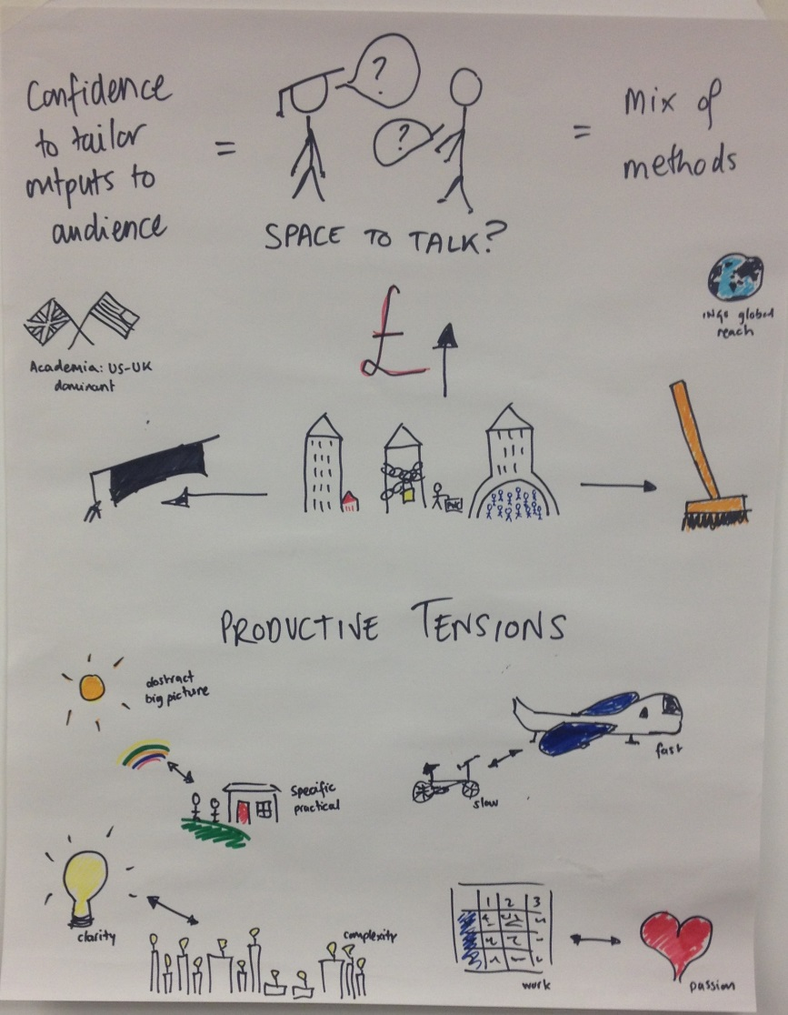
Further reflection led the group to recognise that there are a series of ‘Productive Tensions’ which are really useful in academic-NGO partnerships, and precisely why we should work in partnership together. But in order for these tensions to be productive they need to be named, understood and discussed – to be creative rather than assumed as obstacles. Most important in this is having the space to talk, and the recognition of the role of translation in talking to different audiences.
The pictures in this photo describe these tensions, which include:
- How ‘quality’ is understood is dependent on context – what is quality for one actor may not be quality;
- level of complexity
- space to go fast, or slow
- whether the research is driven by ‘passion’ or ‘project management’
- abstract/big picture thinking or specific and practical
It was recognised that people exist within their institutions, and can take three approaches to how we respond to the institutions we exist in, to:
- work within the confines of our institutions
- bend the norms inside our institutions to make it happen
- work outside the confines of the institution

Practices (literacies, skills and capacities)
This group used a ‘power flower’ to understand what practices we actually use (yellow), the ‘dominant framing’ for our practices (orange), and the alternative practices (pink). They recognised that once you are thinking about alternatives you can think about the dominant framework. That although there are systemic drivers that push us towards the ‘orange’ practices we can push back and operate in the ‘pink’ space. They suggested that we could use the flower as a framework to enable conversations between academics and NGOs in terms of jointly identifying/agreeing which practices would be pursued in the partnership.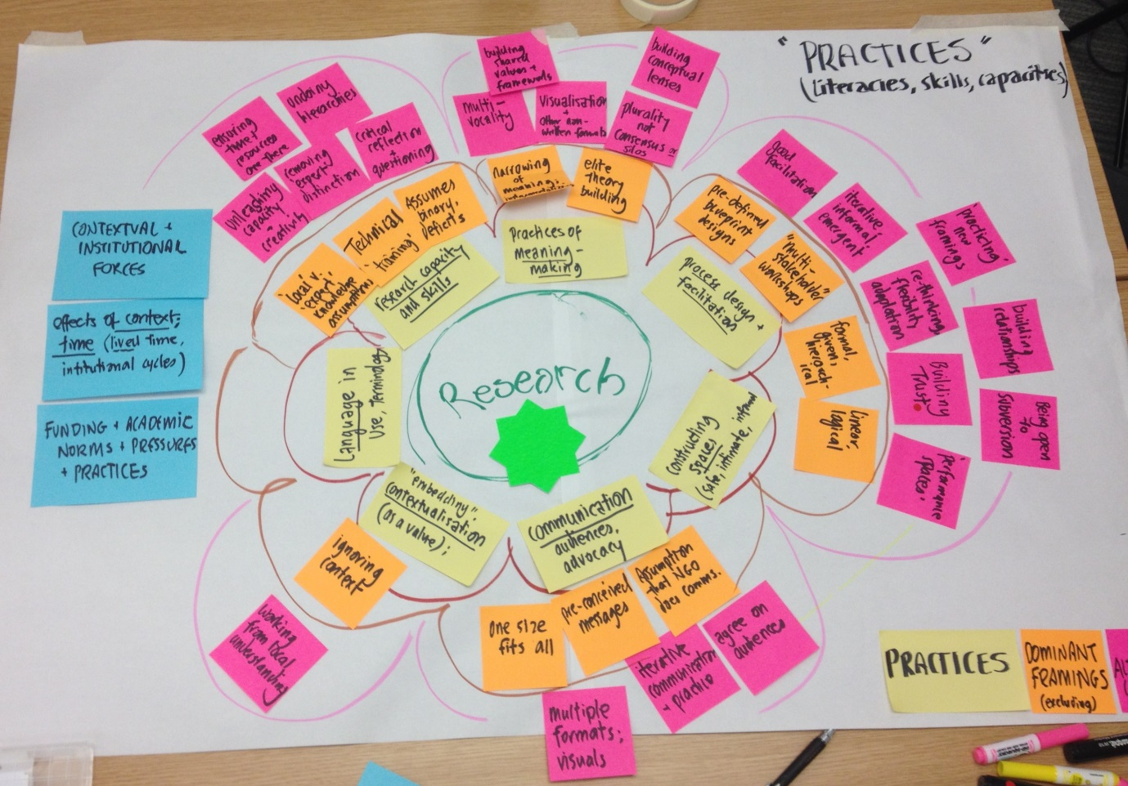
Within the space for practice we need to think about age, gender, religion, identity etc. all these different aspects which shape how we interact with each other, these need to be named and understood and then we can start thinking about how we actually research together.
Reflections and suggestions going forward
Overall conclusions/insights
Time and space is crucial to ensure partnerships work well, and that what is produced is useful for all the different partners involved – academic, NGO, based in the global north or global south. There can be as many tensions and differences between academics, or between NGOs so the concepts are not exclusive to academic-NGO partnerships. However, there are clear differences between academic and NGOs as institutions – with NGOs as development institutions while universities are not, this creates different space and opportunities for each.
The role/relationship with partners in the global south is key and we are not hearing their voice enough in this process – so we need to look at how to bring their voice in (in the final conference?)
There was a feeling that as a group we need to distinguish between long term partnership relationships and project focused partnerships, as these present very different dynamics, opportunities and challenges. In ‘engineered partnerships’ objectives and expectations can be misaligned – and the donor/funder plays an important role in order to provide the space for the development of real collaboration. Within partnerships there is a need for ongoing space to continually revisit the purpose of partnership and ensure that it is shared/understood.
Within partnerships more generally there are lots of different dynamics that exist, but we should see these as a strength – working to bring things together, work with productive tensions, exist in complexity and be comfortable with this rather than trying to force everything to follow one linear path. And we should avoid characterising things as binary, we all move backwards and forwards along different dynamics at different times, we need to recognise complexity and nuance. This means we need to live and practice our values, create spaces for new thinking/practice and nurture space for collective agency. It is also important to be self-aware – recognising how we might constrain ourselves in these partnerships, and looking at how we can work at the margins and push the boundaries – to be creative even if there is little apparent leeway. This also means understanding the bigger picture, if a partner is seen to be ‘irrational or unhelpful’ what other purposes might they be achieving (e.g. status, institutional recognition, NGOs as research aware etc.)
We need to make the case for space to talk within our own institutions, and collectively play the system – especially in longer term partnerships which are not dependent on one source of funding. We can look at how to bring different bits of funding into the partnership, to enable rather than to constrain. We should focus on ‘tendering’ for a partnership, rather than for a project.
If the process is good, i.e. there is co-creation of knowledge through the process, the outputs don’t matter so much, they can (and should) be targeted for different audiences, recognising the sorts of evidence needs that they have. Although within this there is still the challenge of whose voice/knowledge counts, and how one piece of evidences feeds into a dominant discourse of what is valued as evidence. This leads onto questions of whether we are just tinkering at the edges or trying to transform the bigger picture – are we producing knowledge in a rational model to improve practice/policy or are we part of a movement towards change.
It is helpful to have a structure to enable collaboration.
Suggestions for our process going forward
Morning sessions should have shorter presentations and longer discussions, with case studies and agenda circulated earlier – then the presentations and group discussions will be more focused and deeper/more reflective.
It would be good to explore more the ‘space to talk’; exploring how we sell partnership within our institutions, how to make space for the relational /unfunded bit of partnership.
Produce a set of practical tools or research partnership frameworks (targeting different actors - e.g. if you are an academic, an NGO senior manager, M&E person etc ) – as an output of the series, for example the power flower worked really well.
Need to discuss further the question of what is good evidence – what different perspectives and priorities exist in the room, and what does this mean for our own process. Maybe we could start from the ‘evidence’ side, rather than the ‘partnership’ side, and understand what different evidence means in terms of how partnerships evolve? And where there is space for transformative potential.
Comments on the framework:
- narrative needs to refer to broader discussions of partnership/how people make sense of partnership so that it is not just focused on the specific partnership but the meta-narrative that influences how people make sense of and describe their partnership.
- Practices: recognise the role of advocacy/influencing/audience/ research communication and uptake – balance methods and processes
- Institutions: needs to include system dynamics – this could also be part of the context so that we understand systems dynamics as part of the context, and institutions exist within this
- Should we have a more explicit category related to space: how space (physical or procedural, real/actual or dialogical/ideas) can influence research process and outcome
- Overall: A need to focus on the connections between different elements of the framework – both in terms of the different elements of the framework, but also the different stages of partnership – this may be particularly important in longer term partnerships rather than project based ones.

