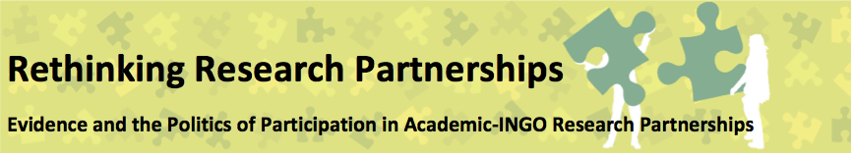

SEMINAR 4: IMPLEMENTING RESEARCH IN PARTNERSHIPS
24th February 2016: HIV/AIDS Alliance, Brighton
SEMINAR REPORT

The third of the four ‘core seminars’ focused on the nuts and bolts of research within partnerships. We started the day by thinking about the meaning of ‘implementation’, how it relates to our broader framework for analysing research partnerships, and what it means for the issue of evidence. We then heard presentations from two partnerships and discussed them in relation to our broader experiences, guided by our evolving framework. In the afternoon, we split into three groups to analyse the case studies through different lenses. We finished the day by discussing potential outputs from the seminar series.

1. Working definitions

The first session of the day was focussed on developing a common understanding of research implementation and thinking about how it relates to broader process of research partnerships and to the central issue of evidence. Participants were asked to position themselves on a scale in terms of how involved they were in the ‘implementation’ of research in their partnerships. One side of the room represented full responsibility for research implementation and the other side represented no involvement at all in this part of the research.

It was perhaps unsurprising that there was a tendency for the more academic participants to see themselves as heavily involved in implementation, and those working for NGOs to be less involved. However, while NGO participants saw themselves as less involved with ‘doing research’ they were often more involved with aspects such as commissioning, supervising, supporting, reviewing and facilitating connections. In some partnerships, both participants found themselves close together in the middle of the spectrum. These examples tended to be those based on close individual relationships or those adopting explicitly participatory approaches to research. Reflecting on this discussion we felt that different ideas about what counts as ‘evidence’ contribute to different ideas about whose skills count when it comes to implementing research. At the same time, sometimes practical constraints (like lack of time and different professional obligations) determine who is involved and to what extent.

From this exercise, a common understanding of implementation was generated that included the more traditional elements of ‘data collection and analysis’ as well as aspects such as: coordination; facilitating connections and negotiating organisational politics; negotiating ethics; training, supervision and support; monitoring and reviewing; and holding the ‘global picture’. Participants raised the challenge of seeing ‘implementation’ as separate from the other phases of establishing partnerships, designing research and communicating research. We discussed the relationship between thinking and practice and whether writing and analysis are separate or have a more symbiotic relationship.

In the second part of the session, we started thinking about the relationship between implementation and evidence. Participants were asked how the PURPOSE of the research they conducted shaped understandings of what counts as evidence, and how this influenced the ways in which the research was implemented? Some of the different purposes of research are summarised in Box 1.

BOX 1: PURPOSES OF RESEARCH

- Documenting ‘what is happening’ (monitoring)
- Providing legitimate evidence of ‘what works’ (either for accountability or for organizational learning) (summative/formative evaluation)
- Challenging or engaging with the existing evidence on a particular topic or issue (exploratory research)
- Solving a specific practice-based problem (explanatory research)
- Trialling or testing a new method, tool or approach (innovation/design-based/developmental research)
- Improving the research capacity of individuals, organisations or networks (capacity-building)

Participants stressed that these purposes were far from the only ones (for example, some research might have an explicitly participatory or transformative purpose – e.g. Action Research) and that in reality, most research partnerships integrated a number of different purposes. But thinking about some of these different purposes might help us to understand some of the tensions in partnerships and why certain types of evidence, knowledge and skills are valued more than others. While there are some traditional types of evidence associated with these different research purposes (e.g. quantitative assessments for evaluation research) participants also gave examples of innovative types of implementation (e.g. Participatory Systemic Inquiry) that could generate unexpected types of evidence.

2. Partnership Case Studies

In the second session we heard about two very different research partnerships. The case studies were structured in relation to our analytical framework into three parts and explored:
- context;
- power in partnerships; and
- power through partnerships.
As with the previous case studies, we have limited the details to keep the partners anonymous, but the following gives a broad overview of the two presentations.

CASE STUDY 1

The first partnership was not framed by a specific project or institutional arrangement, but was rather a series of mutually beneficial collaborations, between an academic (who occasionally brought in colleagues), and a number of senior management at the NGO. The partnership did not have its own project objectives. Rather, it allowed the partners to advance their respective priorities through points of contact, disruption and surprise. There were many elements in this collaborative partnership that enabled it to interact well:, respect for each others technical competency, having comfort with taking risks, being able to act positively together in spite of ambiguity and on- going change, and particularly on the side of the academic, to have the political skills to manoeuvre in a complicated NGO environment.


Key issues emerging from the partnership

- The goal should not be about coming to value the same things, but rather, about coming to understand what is of value from the other’s perspective
- At the same time, there does need to be some alignment of institutional priorities – for example, in this case, both organisations prioritised publishing and demonstrating impact
- The personal relationship between partners is key, as is a shared passion and commitment to the issues
- Flexibility is crucial, as is the freedom for both partners to focus on what is of genuine interest to them. (This may actually be easier when there is limited funding) Ambiguous ToRs can help to accommodate this
- Partnerships need moments for reflection and learning to reassess what is of value. In this case, the seminar series provided such a space
- Research methods should be appropriate to the context and capacity of the partnership. In this case, methods were chosen which were global/comparative and so did not rely on in-country researchers interpreting the design
- A key challenge relates to different views on what evidence is and how it is generated/used – partnerships may benefit from NGOs becoming more ‘research active and research aware’ and universities embracing the role evidence plays in improving programme delivery

These are images that express the nature of our partnership – intertwining strands. Each partner has their own set of perspectives, environment, priorities, goals and understandings. Periodically, we have come together for a moment of collaboration, where we produce something jointly that we could not have produced alone. Our outputs have more or less interest to each of the partners, but each has left the episode of partnership with something new, something different, to continue on our somewhat different paths. We have continued with our own programmes of work – and then we have found another opportunity to collaborate again. Hence the metaphor of interwoven strands – repeated episodes of interaction, each time returning to our ‘home’ set of institutions and practices, to continue the journey, with something a little new in our backpacks.

Context and purpose

At the core of this partnership was a strong relationship between two individuals who shared a passionate interest in and commitment to their shared fields or work. Originating with a call for research support by the NGO, the partnership continued to grow informally, with on-going points of collaboration. Interestingly, the two partners had very different motivations for coming together to do research. The NGO partner wanted to improve their understanding of ‘community mobilisation’ and to review the evidence about whether or not it works. The academic partner was more interested in generating peer-reviewed publications and contributing to academic debates on community mobilisation.

Since there wasn’t much of a budget, it was important for both partners that they could justify the partnership in terms of their own professional obligations. However, these initial purposes did change a bit over the course of the partnership. For example, the NGO partner used the study to develop a Theory of Change and related results framework, while the academic partner developed a critique of the ways universities are understanding ‘impact’. While in the initial stage there was some funding provided through the NGO’s own strategic funds (and later a modest contribution through the university’s funding for doctoral research, and a small externally funded commission ) the majority of the investment was in-kind, and consisted of he time of the lead researchers. While there were clear advantages to a partnership that wasn’t defined by project-based funding or donor objectives, this also proved to be a challenge. Not having a funder to report to allowed freedom in the partnership to adapt, evolve and to address different interests and concerns – but it also meant that there were no externally imposed deadlines or deliverables. Finding time for publications and further funding proposals has been very difficult.
[A colleague at the NGO suggested conducting research around a new “test and treat” intervention] As a researcher, my ears pricked up! A novel treatment – ticks the ‘contribution to the literature’ box. AND, things not going as expected: a perfect rationale for a qualitative study to investigate why people were not behaving as the guidelines presumed… But as we learned more about the particularities, the rationale began to unravel, and the ‘ideal case’ began to seem less and less ideal. First of all, … it turned out that they were becoming more successful in persuading their ‘harder-to-reach’ clients to take up treatment after all – so our framing in terms of a ‘puzzle’ that research could solve lost traction. Nonetheless, we reasoned that there was still something worthwhile in just studying how people understood and responded to this new model. But through further communication, we gradually realised that what we were referring to as “test and treat” … was not the same as what the NGO was referring to as “test and treat”. Our [NGO] colleagues listed a number of research questions that they would have liked to have answered… But for us as researchers, these were local-level fact-finding questions, rather than questions that opened up novel areas or stood to advance knowledge. We had hoped (in the original framing of the ‘puzzle’) that we could conduct research that would both be useful at a local level, and as a contribution to international literature.

Power in partnerships

Within the partnership, a number of factors influenced the types of evidence that were valued and thereforehow the research was implemented. In the extract to the right, the academic partner gives an account of a particular research collaboration that was ultimately abandoned due to conflicts in research priorities and ideas about what is of value as ‘evidence’.

Through reflection and discussion with her NGO colleague, the academic realised that while research seeks out a simplified version of the field, interventions are never straightforward; the real world is messy, and interventions evolve – as they should – in response to local needs, opportunities and constraints.

A further reflection on power relations to the level of engagement – so that for example, the academic partner was able to play the role of ‘critical friend’ in relation to the individual pieces of work of the NGO in a way that was friendly and mutually supportive. But it was harder to engage in discussions around a bigger picture critique “[I had]a niggling feeling that the aid system of which the INGO is a part is a major part of the problem. If communities’ ‘capacity’ needs so much ‘building’, why has an aid system that requires such complex bureaucratic competencies and demands come to thrive? Whose ‘capacity’ is being ‘built’ and why? Why is ‘capacity’ defined so much in terms of competencies in management and bureaucracy, and not in terms of local leadership and community mobilisation competencies? These kinds of questions are not practical questions. How might they be addressed in an academic- INGO collaboration? – this is an open on-going question.” These deeper questions which strike at the heart of development practice are much more difficult to engage with through discrete research collaborations.

Power through partnerships

What did the different partners gain through the partnership? Did the partnership give them new powers to advance their goals? And how did particular approaches to implementation generate unexpected types of evidence?

The INGO partner highlighted the word ‘serendipity’ as key to a “collaboration that has been characterised by surprises!” Over the course of the research it was one of the less intentional outputs - a ‘Theory of Change’ (ToC) for the INGO that turned out to be the most influential: “the ToC exercise led to several outputs that help describe what we do. This basic description then helped us determine how to not only describe our impact, but also to develop indices for measuring both medium and longer term outcomes. This in itself is an evidence-based approach. Which means the result of the partnership meant that not only were we better able to define community mobilisation, in the act of doing this we are becoming more evidence based.” What was interesting was how both institutions took forward their learning from the partnership in different ways, without needing to further engage with each other. The INGOs work on the ToC was done without the support of the academic partner.. In a similar way, the review part of the initial work provided the basis for the academic partner to write a further paper critiquing systematic reviews and considering alternative ways of thinking about compiling and assessing evidence, based more on the realities of practice.
Lessons learned by partners
- The academic partners gained the opportunity to explore concepts and issues in a concrete, real-world environment, problematising some concepts (systematic review), clarifying others (community mobilisation), and worrying about yet others (aid, ‘capacity building’). They also had the satisfying sense of working with practitioners towards common interests in community action.

- The INGO partners gained a new perspective on their own work (theory of change of community mobilisation), which helped inform a more suitable results framework, and a way of working that engaged more actively with evidence-generation and evidence-use.

CASE STUDY 2
Key issues emerging from the partnership

- The major success of the partnership was its impact on the nature of evidence produced. The combination of being able to work through INGO networks and processes and combine this with the university’s strong methodological knowledge helped generate extremely rich insights at multiple levels.
- Despite the differences between the partners, both were committed to a clearly defined (methodological) approach
- The ‘emergent’ approach suited a process where the direction of the research could be realigned over the course of the project. The key issues here were a long-term relationship; a process that was co-evolved; and a process that was iterative.
- At points the partnership hung by a thread and was almost entirely reliant upon the commitment of a few select individuals – so personal passion/commitment and good relations are vital
- The continued volatility of the INGO’s internal structure meant that the ability to influence change has been largely dependent on the presence of senior champions.
- ‘Unintended’ impacts on individual members of the team included several individuals pursuing more research-oriented careers, inspired by their involvement in the project.

Context and purpose

In contrast to the first case study, the second partnership discussed was a project-based collaboration funded over two years and led by a research team in a university and an INGO but with multiple in-country partners (including NGO staff, community members, volunteers and local decision makers). At a far larger scale than the previous partnership, the research covered five countries with the aim of examining how and why volunteering contributes to poverty reduction and sustainable change. Though the research was project-based, initial conversations between the two lead organisations began well before funding was secured. This then grew into a desire by both parties to conduct a broader piece of work that looked at the role of multiple types of volunteering, drawing on examples from the INGO’s programmes and external examples.

A central interest shared by both partners (but part of the on-going work of the research institute) was in participatory processes and especially large-scale and multi-level action research processes.

For the academic partners, the research provided an opportunity to model a long-term process, which extended learning horizontally in communities and upward into the organisation. The partnership was long-term and evolving, and it also contributed to their goal of building a network of ‘friends’ who were keen to embed and champion participatory processes in their work.

The INGO was first and foremost interested in generating research on the difference that volunteering made (positive or negative) to the local communities that the volunteers engaged with. This was partly a response to strategic change in the organisation and partly a response to new pressure to demonstrate ‘impact’ from their primary funder, DFID. The INGO hoped that this research would help them to improve their own organisational practice as well as making a contribution to the international literature. As well as providing an ‘evidence-base’ for their programmes and organisational development, they also hoped to draw on the expertise of the research institution in participatory approaches that might be implemented across theirs own processes and practices. In this way, there was also a ‘capacity-building’ purpose to the partnership - they were interested in the process as well as the findings.

INSERT VISUALISATION HERE – CREDIT PAOLA ROSO

Power in the partnership

The case study revealed a number of examples of how power operated in the partnership, the tensions it caused (or might have caused) and how it was negotiated. Key issues included:
- Decision making: this was primarily a collaborative process (though somewhat jeopardized by staff-turnover) Each partner played a clearly delienated role in the management of the in-country researchers with the academic partner responsible for their research and the INGO responsible for their in-country experience
- Research training: the researchers received methodological training from the academic institution (as well as the standard training from the INGO) Training was positive, however, lack of research training to in-country support staff created some gaps in understanding
- Collaborative analysis: At a global level, a series of collaborative workshops were conducted at stages throughout the research process which brought the lead researchers and the partner organisations together. There was also a final ‘global analysis’ workshop
- Lack of shared understanding about the purpose of the research and the wider purpose of emergent research: Those less directly involved in conducting the research found it sometime hard to understand exactly what was being done and how it might be turned into something that they could use. A lot of time and resource was invested by both partners in protecting the application of the methodology and preventing the research from being usurped for other purposes. This was helped by both organisations collaboratively producing a number of internal and external communications that shared emerging findings from the research on an ongoing basis. The INGO Project Manager was also able to call upon the university partner to lend ‘academic weight’ in some internal meetings.
- Emergent methodology: This put a lot of responsibility in the hands of the individual in-country researchers to use their intuition and skills to respond to unforeseen issues. Some thrived on this independence while for one the pressure was too great and they were not able to complete their research.
- Tension over what evidence is published and key messaging: The concern on the INGO’s side at one point was that the findings had been presented in an overly negative way and that whilst they wanted to be honest about the challenges encountered, they were worried that the way the evidence was presented appeared to present their organisation in a bad light. From the academics’ point of view, they felt that INGO was trying to be a ‘red pen censor’ at points.
Power through the partnership

What did the respective partners learn through the partnership? What did they achieve and what changed within or beyond their organisations as a result? To what extent did the research partnership give them new powers to advance their different goals?

The Box below highlights the key points of learning for the INGO and academic partners. As well as application of the research findings, process and tools to institutional policy and practice, the partnership also generated a shared commitment to developing a stronger political and contextual analysis of the INGO’s programmes, contributed to national level discussions on volunteering and helped to create a new ‘learning architecture’ within the INGO that ensured that learning from the research was embedded back into the organisation. Crucially, the research also generated a sound ‘evidence-base’ to present to the INGO’s main donors.
Lessons learned by partners
- As well as learning from the research findings themselves, the INGO was also able to draw on learning from the approach, process and tools to make key changes to its programmes and organisational practices (e.g. use of participatory visualisations by the Monitoring Evaluation Research and Learning team and embedding action research cycles in the design, implementation and review of its programmes with a focus on more reflective and adaptive programming)

- The academic partner gained important learning about the opportunities and challenges in developing a new type of longer-term and evolving partnership. While not everything worked in this particular partnership (largely because of staff absences) it provided a stepping stone to the sort of relationship they went on to develop with another INGO where they effectively tendered for a long term research partnership rather than the delivery of a contract.

Both partners agreed that the major success of the research partnership was its impact on the nature of evidence produced, which went way beyond the initial scope of exploring the value of volunteers. The combination of being able to work through the INGO’s networks and processes and combine this with university’s methodological expertise enabled them to generate extremely rich insights at multiple levels. However, there was a challenge in sharing this rich evidence with key stakeholders - it has sometimes been ‘dismissed’ as just a piece of research on the topic of volunteering, when in reality it provided many more insights into the pitfalls and challenges of international development and how these could be overcome.

The continued volatility of the INGO’s internal structure meant that the ability to influence change was largely dependent on the presence of senior champions. However, it also presented opportunities that may not have arisen otherwise, with the introduction of new ways of working and an increased emphasis on strengthening the INGO’s evidence base, opening up new spaces for influence.

Finally, perhaps some of the most significant transformations have been the ‘unintended’ impacts on the individual members of the team – many of whom went on to pursue their own research careers.

3. Analysing the Case Studies
(Implications for implementing research in partnerships)

As we listened to the two partnership case studies we used post-it notes to write up examples of factors that had influenced how evidence was understood and negotiated through the implementation of research in the two partnerships. We used our evolving framework to organise these factors into the following categories:
Examples of ‘institutions’
In the first case study the academic ‘impact agenda’ and corresponding ‘Research Excellence Framework’ played a key role in determining what counts as legitimate research outputs. Pressure from donors to demonstrate a strong ‘evidence-base’ for programmes (such as that experienced by the INGO in the second case study) also influenced the purpose of the research
- Institutions
- Identities
- Practices
- Artefacts
We thought about how these various factors influence the ‘evidence landscape’ in which partnerships are situated (in terms of what types of processes and products are valued and why certain institutions or agendas have particular status); how they influence decisions about what types of approaches to implementation should be adopted (for example, which methodologies to use and what types of training, support and infrastructure is needed to facilitate this); and how they might themselves be transformed through innovative approaches to implementing research in partnerships.
Examples of ‘identities’
Both case studies reaffirmed the importance of the interpersonal aspect of partnerships with good interpersonal relationships crucial to the success of the research. The second case study also showed how ‘researcher identities’ were developed in many of the NGO participants to the extent that they went on to pursue more research-focussed career paths
Examples of ‘artefacts’
Tools and texts such as ‘peer-reviewed publications’ and ‘Theories of Change’ were identified by both case studies as having either symbolic power as a legitimate piece of evidence or the more instrumental power to influence institutional practice. Across both these case studies is the unintended consequence of how research into programme practice influenced internal monitoring, evaluation and learning frameworks and what partners/ country offices were expected to do and report on in their annual processes. The nature of evidence and the nature of partnership was very different in each case, as was the organisational context but the most immediate response in terms of the research findings was in relation to organisational reviewing and reporting systems.

Examples of ‘practices’
In terms of implementing research, key practices included methodologies and particular approaches to research. These research methods created a common ethos and gave the labels gave legitimacy to the research itself in the eyes of the NGO (ie the senior staff in the NGO did respond to the evidence generated through these processes).

In the afternoon session we split into three groups to attempt a more in-depth analysis by focusing on different aspects of the relationship between implementation and evidence. The first group looked at how the context and purpose of partnerships are shaped by the evidence landscapes in which the partnerships are situated. The second group explored how different notions of evidence shape the way that research is implemented in partnerships. And the third group considered how different approaches to implementation might generate new types of evidence. Each group was asked to draw on the case study presentations from the morning (as well as the previous case studies presented earlier in the seminar series and their own experiences) and the factors identified above to identify some key questions which might help future research partners think about evidence in these areas.

Group 1: Context and purpose

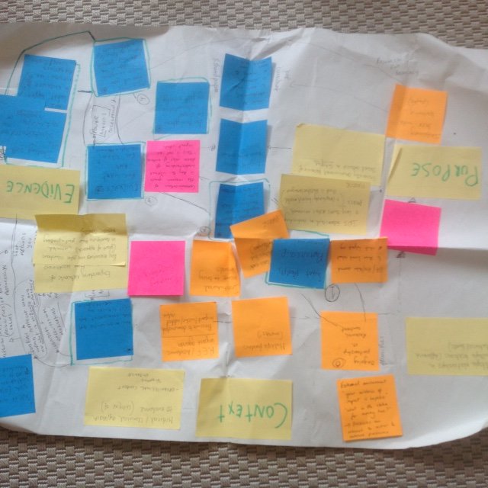

The first group used the metaphor of ‘speed-dating’ to think about some key questions worth asking potential partners before committing to a research partnerships. These included:

- What type of partnership are the different parties looking for? E.g. – an ongoing relationship or a project-based/contractual relationship.

- What prompts the partnership and what is the trigger point (for individual partners and as a common aim)?

- What are the personal/organisational motivations, interests, agendas, incentives and structures of each actor? How do you ensure both individual engagement and institutional buy in?

- What is the evidence partners want to generate? How is evidence understood by different parties? Who is the evidence for? What is the evidence for? What levels of evidence generation and different types of stakeholders are involved?

- What type of power-relations exists in and amongst stakeholders and how might power imbalances be disrupted?

- How will you enable emergence and iteration in the partnership process (i.e. what do you do when different types of evidence emerge from what was originally intended)

- How does the research methodology respond to the principles of the organisations in the partnership?

Group 2: How evidence influences implementation in partnerships

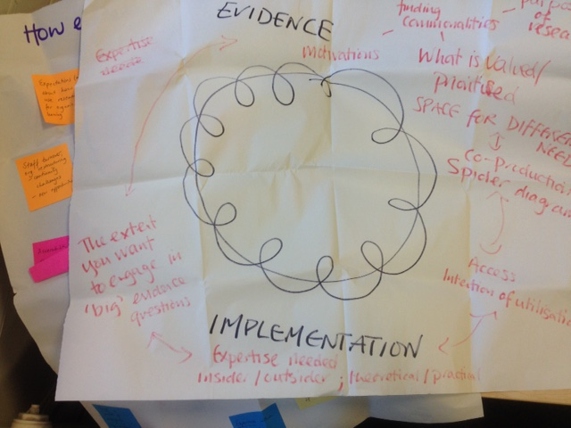
The second group started by highlighting the key factors accounting for power within the partnerships. These included:
- Expectations about how to use research for organisational learning
- Staff turnover, organizational restructuring – challenges, continuity, new opportunities;
- For one of the academic partners the evidence produced prompted further reflection on the nature of ‘capacity building’ (and difficult questions about the role of NGOs in development)
- Institutional openness to listening to critiques from the coalface
- Representativeness (whose voices are captured)
- Research practices, e.g. participatory research methods or evidence interrogation, getting picked up as part of NGO organizational change and learning
- Experience within a partnership providing both individual and organisational learning for future partnerships
- Trust in context of ambiguity – e.g. emergent research different languages
- Systematic review (context-inconclusive)
- Peer-reviewed publications
- Challenge of pinning down a single intervention to study
- Ethics (ownership- national inquiry groups) but less good at feeding back strategic implications of evidence
- Framing findings in such a way that will be taken up, rather than rejected as criticism
- Inconsistent training – different understandings/research capacity between researchers and country offices
- Strategic funding for research in NGOs
- UK based methodological approaches
- Literature review (evidence on benefits to volunteers but not of benefits of volunteers to development)
- Accessibility and resonance of research artefacts to NGO audience
In order to organise these factors, the group started by thinking about the motivations behind evidence production and identified the following questions that new partners might ask themselves and each other:
- What was the purpose of research – was it in response to a specific funding call, what conditionalities existed in the funding call? What motivated you to get involved in the research? What bottom lines to you have?
- What did each partner value and prioritise (in relation to evidence)? How does the way different partners perceive evidence influence implementation? How can you both meet your aims? Is there space for different needs to exist? What does co-production mean in this instance/at different points during the implementation?
- What expertise is needed/valued, how do different methods impact on who is considered a legitimate researcher – who is the researcher and how are they qualified, for example should the research be done by an insider or outsider; is theoretical or practical knowledge needed?
- Is the issue a ‘hot’ issue or a ‘critical’ issue – how does this impact on the framing and conceptualization of the research?
- What is going to be done with the research – who will access and use it? Is it to generate knowledge, or is it to be used to make a decision?
- To what extent does the research want to engage with the ‘big’ evidence questions? I.e. is the research just trying to understand a specific issue, or is it trying to impact on what is considered valid research process/output/types of evidence. (i.e. is it fine for the research to be done collaboratively and then the academic to write up an article for a peer-reviewed journal, or is the intention also to challenge the types of knowledge that are published in a peer reviewed journal?)
The group placed these questions around a messy circle, with a line that criss-crossed it looping around and around (see photo above) to illustrate how implementation is not a static moment, how it can be iterative, and answers to the questions may vary at different stages in the implementation.
Group 3: How evidence influences implementation

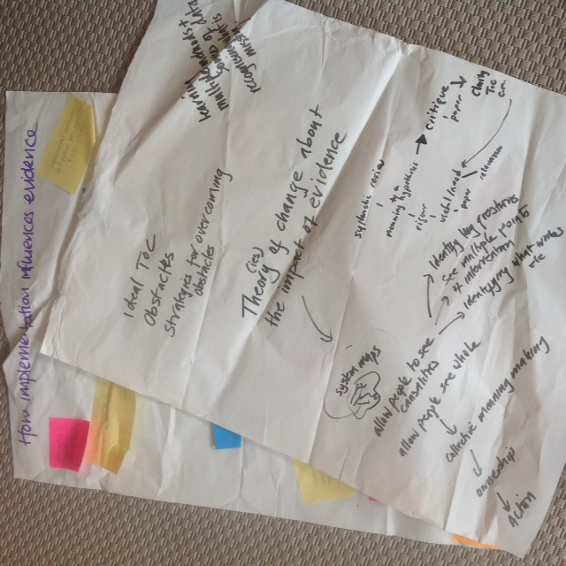
Finally, the third group started by brainstorming some of the innovative approaches to implementation that had emerged from the case studies and the group’s own experiences and thinking about the ‘alternative’ types of evidence that were generated as a result. A key question identified was:
how to create processes that allow people to make sense of their own realities? What types of ‘data’ could this generate? What types of ‘tools’ are needed?
After agreeing on a set of principles that should guide this approach to implementing research (including a participatory ethos; emergent/iterative methodology; healthy ambiguity; strong relationships/communication; and the aims of generating transformative evidence) the group thought about the relationship between process and product (or implementation and evidence) concluding that in a participatory approach these dimensions can be blurred. For instance, a ‘systems map’ is both methodological tool and evidence in itself. It might therefore be helpful to consider multiple levels of evidence and the relationships between these.
As a pragmatic strategy to help partners think through the relationship between implementation and ‘good’ evidence, the group proposed developing a ‘Theory of Change of the impact of evidence’. This might involve the following prompts:
- What are the ideal ToCs for evidence/impact? Individuals reflecting on their own ToC compared with each institution’s ToC
- What are the obstacles to achieving this?
- What are the strategies for overcoming obstacles?
- Importance of understanding multiple purposes/ideas of evidence/uses of evidence
- How can space be created for emergence and learning
- Recognising what’s missing – gaps in evidence – notions of system maps/systematic reviews
In the plenary session, the three groups presented their responses and we spent some time looking at common threads (e.g. importance of agreeing on key principles in which partnerships can be grounded) and thinking about how the tools generated might be drawn together as an output of this seminar series – see following section.

4. Key outputs, wrapping up and links to the rest of the series

Designing a resource pack
The final session took the form of a plenary and focused mainly on thinking about the key output of the seminar series: a sort of ‘resource pack’ for helping research partners think about evidence as they establish partnerships, design and implement research, and communicate findings.
Responding to the questions of ‘what have we learnt that would be useful for new partnerships’ and ‘what/how can we learn from failed partnerships’ participants suggested the following points as key to the resource pack:
- Provide guidance on how to initiate a partnership with different stakeholders
- Develop questions to help both parties at the outset of a potential partnership (See above group activity for ideas):
  - What are the values that underpin our partnership? Explore values of each organisation and identify overlaps.
  - Insert questions to help us to decide whether to go forward with partnership or not and how to exit if necessary.
- Include examples from the case studies as well as ‘failure vignettes’ which are often omitted from ‘best practice’ handbooks
- Provide tools (e.g. on ‘mapping the evidence landscape’)
We also discussed the target audience for this output (primarily INGOs and academic institutions) and how it might be disseminated through various networks and institutional channels.
We also discussed the issue of anonymity in the case studies: do we want to share them in their entirety or do we want to identify questions/themes to pull out and use case studies to illustrate?
Logistics for next seminar
In preparation for the final core seminar participants were asked to think about how much time they can commit to case study development or resource pack or developing a blog or theme into more substantial publication; and where their preference for contribution are.
ESRC series finishes in June 2017 by which we need to produce at least two outputs/collaborative resources.

5. Reflection on the day

Participants offered the following insights and suggestions in a reflection on the day:

Insights:

- Some outputs have a moment. We don’t need to plan for them as permanent artefacts.
- Challenge of allowing for and fostering emergence and serendipity
- A main intermediate outcome of partnership is “collective meaning making”
- Designing “learning architecture” and info flows explicitly, upfront as key component of research project
- Trigger points as identity/existential crises (engagement with core approach) for engaging in a research partnership
- ‘Emergence’ and the notion that unintended evidence can be more useful than the original intention
- I really enjoyed the time given to the case studies, discussions and the informal way within which conversation took place
- I also liked the fact that the group is fermenting a shared understanding about the issues being discussed
- Defining our purposes is very useful – the overlaps might be surprising!
- Reflecting on each partner’s values (and not just making assumptions about similarities/differences) is a great starting or mid-reflection way to assess partnership ‘match’
- Where are primary actors in research partnerships? – always link back to who benefits from the research – action research is a mechanism for involving primary actors in the process and sharing benefits
- It may be okay for partners to have different ideas about what evidence is valuable… as long as there is enough overlap goals that influence/shape how research is implemented

Suggestions:

- Slightly too much information in the ‘preparation’ emails – keep to succinct bullets/instructions
- The energy level of the groups seemed a bit low by the end of the day. Probably just to do with tiredness but final discussion was affected by it.
- The division of flipchart into context/purpose; evidence influencing implementation etc. didn’t make intuitive sense to me but the questions to ask made good sense
- Perhaps more experimentation with innovative group work techniques – might as well make use of the opportunity to learn from process as well as content
- No concrete suggestions – great food this time!
- As always, natural light. Not convinced that power in/through framework helps – was glad we let it go
- The questions are good
- Would be good to reflect a bit more from last time, to connect the series together

The next seminar will take place on Thursday 9th June 2016, at Christian Aid offices in London.

Conference will be held in London at the OU, Camden on Tues/Wed 8th/9th November

