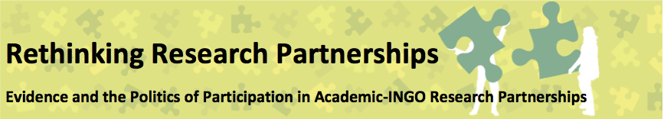
Seminar 5: Communicating research:
9th June 2016 (Christian Aid, London)
Defining ‘research communication’
We started the day by exploring what we understood by ‘communicating research’, drawing on our experience in different partnerships. This included a discussion on:
- Use of different types of resources: reports, guidelines, conferences, workshops, blogs, exhibitions/art work, films. We noted that communication is influenced by format, media, style and venue (in the case of an event)
- How to make communication products accessible: use of synthesis, shortening lengthy documents, translation (into different languages or jargons)
- The process of applying/making applicable research findings: translating findings into practice/policy
- The role of translation: brokering and working collaboratively to communicate across different groups
- The different skills involved – relationship building/facilitation/social skills/knowledge of needs and understandings of different stakeholders
- Evaluation of the research output (e.g. according to ‘rigour’ or ‘science’ or just by the symbolic power of the type of resource)
- Censorship (reputational risk) and whistle-blowing (there were shared experiences of NGO research where the NGO had prevented the research findings from being made public and a discussion of strategies to respond to this)
- Timing of the launch of the resource and links to other resources/events
- Dynamic of internal and external communication (can external communication help encourage internal attention on research, how do the 2 reinforce and complement each other)
- Research outputs must be understood in context – both the context of their design and the context of their reception/use – with the political agendas of those creating and using the outputs
Lessons from the case study
The case study was presented (see background paper for full details) The notes here cover where there was further discussion or where particular points not in the paper were raised / elaborated.
- The context of the partnership influences how it evolves – so where there is a political context that is particularly permissive, or interested in working in different ways/bringing together different groups of stakeholders this can create a context which is more enabling of a complex partnership – for example to explore the way policy is discussed and developed.
- The partnership provided a means of acquiring and bringing together additional resources (either expertise, human or financial).
- The partnership demanded new ways of talking and of thinking by bringing together a wider range of actors with different interests, agendas and languages.
The case study presented the following visualisation as a metaphor for the partnership:
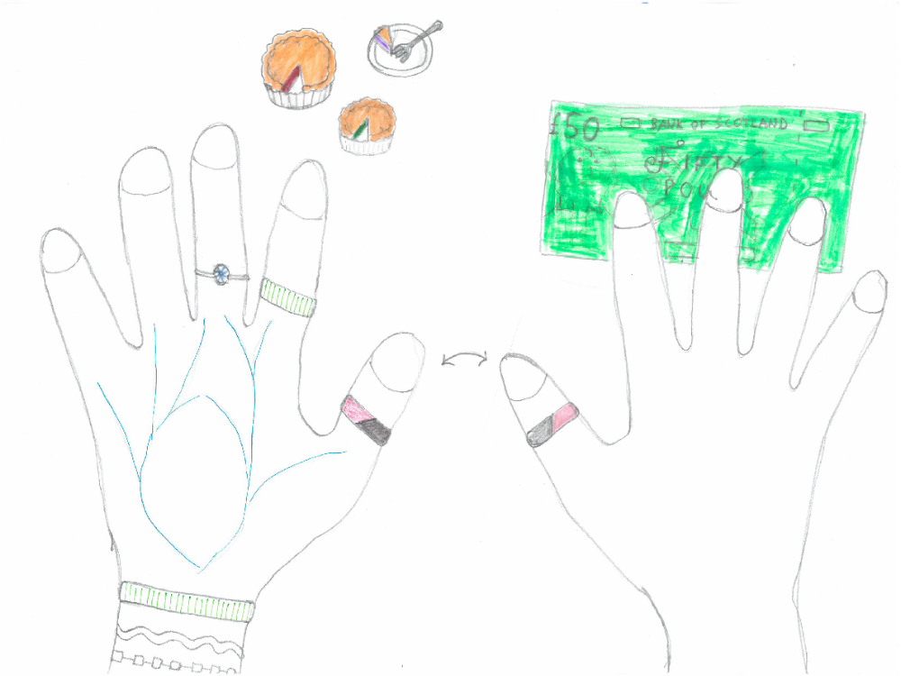
The visualisation is an attempt to represent the partnership - the different actors within the partnership, the resources that they draw upon, and some of the power interactions at play.
The left hand represents the NGO and the right hand is the university. The fingers represent key people in the partnership. The thumbs are the key contacts between the two organisations – the presenters of this case study.
The veins in the NGO hand represent its organisational memory, policies and people that the fingers draw upon to ‘get things done’. They often seek to use the veins for justification of their own preferred position. The bracelets represent the NGO’s (most recent) strategy. This is usually sent down from on high and changes every few years. The fingers are largely expected to embrace and work to it.
The rings represent the types of evidence that individual’s privilege or prefer. The thumb (NGO presenter) privileges evidence that makes the link to issues around power and can be used to shift strategy in the NGO. He also sees the partnership as a way of building capacity and doing ‘interesting things’. The index finger represents the regional head of the NGO who privileges evidence in line with the most recent strategy. The middle finger represents the NGO’s programme manager who privileges evidence that could be used to bring in funding. The thumb on the university hand represents the academic presenter who privileges a similar type of evidence to the NGO presenter. The other fingers represent academics that are brought in as and when required.
The pies represent the NGO’s links to policymakers, civil society organisations and community groups. While the policymakers and civil society pies are fairly full, the pie representing community groups is somewhat empty as in the last restructure and strategic review the NGO significantly cut its core funding for domestic programme work.
The £50 represents the financial resource that the university has put into the partnership. This is largely, although not exclusively, used to unlock the time of academics.
Discussion around the visualisation:
- The external context is missing from this diagram. An alternative image was suggested of a storm, which would highlight that context, the key points being: austerity, low wages, rising prices.
- However a similar representation making these points resulted in a backlash as it was seen as “too political”. This corresponds to a changed context to the partnership: an increasing risk-aversion within the NGO, and a questioning of the insider/outsider relationship to the government.
- Also missing is the two-partner interaction. This could either be represented as a “thumb war”, regarding the outputs of the project, differing opinions on what can be said and in what context and small tensions around changing lines in reports; or as hands clasped bringing together the different strengths for common purpose.

- There was a discussion around “benign neglect” from the university partner in a partnership. The case study partnership was highly celebrated by the university, but not necessarily institutionally supported – in terms of staff time for research input. On the plus side, this neglect allowed for a lot of latitude, to be flexible / agile, and focused on the common agenda.
- Tensions did arise but were worked through. The example given was a critique of the concept of ‘social capital’, produced by the academic partner, which was seen by the NGO as potentially interpretable as an “attack on the rich”. However the piece was not intended to speak for the NGO and was rather an academic argument. This tension was a learning experience. It perhaps reflected the importance of different language between partners and how language is used in reports to communicate research. The workaround was that some outputs were not released as a partnership report, even if drafted as such; they could be published through other means. Perhaps under the ‘auspices’ of the partnership, but not as fully endorsed publications.
- The isolation of individuals was raised as an issue, with lone key individuals often having central roles in a partnership. A lot often rests on single actors and actions, and this has issues for sustainability of partnerships, and highlights a need to build institutional buy-in.
- The ‘volunteeristic culture’ in academia was also raised: a lot rests on the autonomy and individual decisions of academics and this needs to be challenged. Support of and buy-in to partnerships should be made part of an academic workload.
- In relation to the case study, there was a discussion of the practical benefits, or appeal of the partnership to academics. Central was the access to the community partners held by the (I)NGO. Ironically in the case study itself the access to community partners had reduced over the partnership period as the NGO had had resources reduced and was not able to support the same number of organisations.
- A related point was made in reference to the case study: it was envisaged in part as a way of getting academic teaching staff research active. It was hoped that links to community might stimulate this, but in reality it had not happened that much and it was an area for the university to revisit. We also discussed other academic-community partnerships such as Brighton University and CUPP http://about.brighton.ac.uk/cupp/. This was given as an example of an innovative, and widely institutionally supported, and successful example of a local community partnership.
- There was a discussion around the partnership as a means of advocacy for the partners. A partnership agreement can be used to pushback internally, either against changes in policy, or as a means to influence a policy agenda. There was a discussion of how this can be done strategically – through events vs. documents /reports. It was suggested that events are less likely to raise concerns that could be misconstrued (i.e. as representing a defined policy position, rather than a point of discussion).
- The process of finding common ground and working on it was highlighted as important – as projects then get ‘bigger legs’. (e.g researching something that has become important in relation to a national development strategy can lead to the research being more impactful’).
- A point was also raised about the ‘Partnership’ entity being able to maintain positive relationships with organisations, despite relationships with the NGO suffering damage by a withdrawal of funding.
- Finally, it was agreed that that a degree of political manoeuvring within the partnership is always necessary.
Evidence in the partnership: context, power in and power through
- The presenters agreed that the seminar series had been beneficial in making explicit implicit thinking. One of the main points was “Getting real about the role of evidence.” Policy-making is not a rational process, though it is presumed to be rational through the language and ways of operating. It might be ideas rather than evidence that changes things, but perhaps beyond that it may be more accurate to talk of movements changing things?
- The case study partnership was not trying to be a social / political movement, but was to an extent seeking to replicate those kinds of networks to increase the effect of evidence. This gives a context for understanding how the partnership works, and what kinds of work it does. It is a way of building similar ‘ways of thinking’ about things, or issues.
- There was some discussion about ‘research as challenge’. That research can be a means of projecting voices of disaffected groups.
- There was also a question from the floor around context for the case study partnership – that the University is rooted in same community, and the same policy environment, with direct feedback loops; unlike in international partnerships – where the university might be in one country and the community on the other side of the globe. An example from another NGO was raised, “Voices form the Community”. This amplified voices from the community, but these were then challenged by a need to translate them into the language style of donors or funders. The question of how this can be resisted, and what role research methods can play in this was raised.
- There was a discussion around participatory methodologies as a way of gaining greater validity/legitimacy in policy contexts. However it was suggested that this may only be the case if the core ideas were agreed with. Participation can also pose a risk. Audiences who object to the research finding can challenge them through the methodology, questioning their ‘robustness’. This did not come up that often in the case study partnership, but one example was given, where the number of interviews in a project was questioned.
Further reflections on the case study included:
- That research findings may be not getting out to those hostile to the research.
- That communities participating in the research may also be present at launches etc. and that may limit the amount of challenge possible.
- The context of the policy forum and research is part of a collaborative project, so more supportive.
This lead to a brief discussion of the community organisations involved in research, and their different needs from working with the partnerships. Participants noted the differences between groups seeking to changes things (policy / practice) and those simply looking for funding, and so evaluative research that would support funding bids.
A point was raised around which voices are NGOs prepared to challenge. The case study showed that actors are prepared to challenge academic voices, but contrasted with an unwillingness to challenge donor / funder language (e.g. ‘value for money’ discourse). What does this mean for governance structures in NGOs? How are the strategic partnerships situated in relation to the governing structures? The speakers responded that for them the partnership is getting into the regional office of the NGO’s thinking but not feeding up higher, into national thinking because of the structuring of the partnership.
The various different understandings of evidence within an INGO were also identified, e.g. between fundraising, communication, M&E, and researchers. It was suggested that upper leadership are mostly bureaucrats / or at least lacking a research background. This means a limited or biased knowledge around evidence, as it is not their bread and butter work, and they operate at a different scale. There was a recognition that if someone doesn’t like the outcome of research they often challenge the methodology, and use this as a way of rejecting the outcome.
There was a discussion around evidenced-based policy making, and rationality. It was acknowledged that there might be different conceptions of rationality and non-rationality at play. There was talk of a media elite influencing idea of rationality. Someone suggested that sometimes a piece of work / project ‘doesn’t feel like [A NAMED NGO]’, perhaps reflecting a different kind of rationality than within the organisation. There may be different cultural or counter-cultural issues raised through research. However the speaker limited the scope of the critique of rationality to be more narrow: not talking to the wider picture but specifically to the idea of ‘pure’ research, and evidence-based policy. There was never an expectation for the case study partnership to influence the NGO at national level.
There was a discussion about the wider aspects of the partnership as being “Learning partners” rather than purely research partners. A piece of research itself might be over, but carrying on the conversation is also valuable work.
There was a discussion about whether the research projects in the partnership were collaborative from the outset, and who was the driver behind the research? The partnership spoke of an early “speed–dating” between academics and community organisations:- to get sense of ideas and what’s needed from community organisations, to match people, get them together, and start the conversations. Small bits of research support/help were organised in this way, but were not necessarily written-up, or visible, or labelled as part of the partnership.
The positionality the researcher – who would describe himself as an activist and not unbiased in any case, this was very visible in the partnership case study.
Power of narrative: personal narratives in the research had power; and NGOs often produce this kind of research, because of the centrality of a human story. There is an adage that a “story is worth a 100 data points”; within this piece of research the “story emerged from a 1000 data points”; in communicating research to policy makers, making the story is important - politicians have to respond to personal stories.
Communicating and implementing research often go together – so it is less about focusing on a specific research output, but more about taking advantage of opportunities throughout the research process, to communicate, engage others in emerging findings, use reports opportunistically, to influence policy, get funding etc.
2. Communicating the seminar series
We proposed 2 main forms of communication for the seminar series – some sort of resource pack to support others (academics and INGO staff) to develop research partnerships; and a final conference.
We therefore spent a good part of the day discussing these two communication pieces – focusing on:
- why we wanted to communicate key messages from the series;
- what we wanted to communicate;
- who we wanted to communicate to;
- how and where we wanted to communicate.
The table below gives some examples under the four headings.
Why (purpose) | What (content) | Who (audience) | How (media of communication)
To support research and evaluation/NGO and academic research partnerships  As well as a practical tool it should also be able to be used for advocacy – particularly for funders, to fund practitioner-academic research in different ways  We need to recognise that people will use whatever we put out in different ways, you cannot create critical thinkers, just create the conditions for critical thinking | How to guide – it should bridge the conceptual and the practical, (connecting critical reflections and practical experiences – ground it in the seminar experiences)  Use visuals to inspire discussions  A discussion guide for NGOs and academics – with short egs and a focus on critical questions which can prompt discussions  Include aspects that NGOs and academics might want to think about separately ahead of coming together; and then questions to work through together; and then a resource for ongoing reflection to maintain a healthy partnership | People working for NGOs and academics (primary audience)  Research students secondary audience  Primarily UK audience, but hope that some resources will work internationally  For people planning a partnership – with targeting sections branded to specific audiences | Frame it as a series – an online resource (in HTML and PDF) release bits periodically/episodically so it doesn’t overwhelm straight away (trade off between basics and going deep – maybe possible through click-throughs)  Clear structure, short/accessible, open source  Use case studies, vlogs/summarise case studies in short videos/pod casts  Do some blogging and tweeting (punchy, to get critical thinking and exchange)  Interactive (depends on infrastructure and bandwidth)  Think about language/translation possibilities  Sign-post what is already out there,  Could be a discussion guide for a day long workshop – in other research partnerships X,Y,Z has happened, here is how to have the conversation/this are critical questions which are often not spoken about but need to be addressed.  Should be short-sharp and practical  Use info-graphics to sum up key ideas/use of art/clitoracy

Suggestions for channelling some of this into concrete outputs included:
- Series of publications
- Practical Action Briefs
- Pdf / html formats for accessibility.
- Oxfam Research guidelines – one of the most downloaded, in part because of their practicality / accessibility.
- Discussion guide: “so you’re going to set up a research partnership” a guide for having a discussion about the partnership, as a facilitator, resource as facilitator (which could be used for a 1-day/half-day workshop)
- Highlighting pre-work – for each organisation, and then together.
- Methods for partnerships: Power flower exercise, spider-diagrams, providing short visual guides.
Some key questions that need to be addressed in deciding the final form of the outputs:
- Language; Biases towards native English speakers.
- Problems with separating a ‘how-to’ and a journal article, concerns around losing the critical approach in a ‘how-to’ guide. How do we bridge the academic (high level, power knowledge) and practical (how-to)
- How much information do we want to make available?
- Need to flag a part way through check in – to keep critical-thinking and iterative process.
- Need to prioritise, what the key points are.
- Who are we speaking too – global /local/us-us? Dynamics of south-south partnerships, lessons learned from elsewhere. Flagged as important if not included. Speakers to that issue from the south. Or ‘critical friends’ from the south, as discussants (and also from west Scotland!).
- How/should we use the case studies – could they be presented as fictionalised stories, rather than anonymised?
General advocacy points to consider as learning that has come out from the series
- Need to speaking to the ESRC / research councils /other funders – about their grant size, unrealistic understanding of international co-investigators. Clarity on what they will fund / not fund in a partnership.
- Funders to understand co-production in a deeper way, value of bringing donors into this place
- ESRC needs to be ‘more AHRC’ in approach to critical methods.
Designing the resource pack
Based on the discussions of the aim and focus of the resource pack we then split into groups to explore further the content of the resource pack.
We agreed that the resource pack should have three key sections (Establishing, maintaining and exiting partnership; Designing and Implementing Research; and Communicating research), which are pulled together under a narrative of purpose and context of partnerships.
While the pack itself is likely to exist online, and should be dynamic and interactive, we felt that it should be slip into clear sections, reflecting our research/seminar series process.
PURPOSE AND CONTEXT GROUP
Questions:
- What is the ‘evidence landscape’ in which the partnership is situated?
- What are the different understandings/agendas that you bring to the partnership? (personal/(sub)institutional)
- What are the different resources you bring to the partnership?
- What is your track-record in research/partnerships?
- What can you voice/write?
- Who needs to be involved and how?
- What is the influence of donors/funders on the partnership?
- Who are the broader actors that interact with the partnership (or contribute to setting the context of the partnership) and what are their agendas/understandings of evidence?
- What are the risks and opportunities associated with the partnership? (e.g. staff turnover)
- How do partners (and other associated institutions) use and value evidence and why? What type of practice/outputs have led to meaningful change for the partners previously?
Tools:
- Identifying multiple theories of change for the different partners (and within the different partner institutions) – and using ranking matrices to come to some consensus
- Concentric circles of influence – who has the power to change what?
- Participatory (embodied) tools for addressing sensitive issues/power dynamics
- Diving the group in different ways – reflecting as a plenary, in small groups or individually
- Pros/cons matrix around the benefits of individual versus institutional partnerships
- Above/below the ground visualisation/mapping of evidence production and use- and re-mapping at different stages in the project
- Power/relational mapping of all the actors involved in the partnership (chapatti diagram?)
- Mapping institutions to ensure the partnership is appropriately embedded in institutions and not just sustained by individuals
- Metaphors of ‘partnership’ – visualisations, discussion and exposing limitations of the different metaphors
- Describing assumptions about the ‘other’ partner (drawing stereotypes of the ‘other’) and focusing on the types of evidence valued
- Anatomized personal reflections/concerns discussed as a group
Examples:
- Difficult aspects of power dynamics
Advocacy target messages
- Hierarchies of evidence exposed
DESIGNING AND IMPLEMENTING RESEARCH
- Areas to consider:
Time/scope/institutional resources | What kind of evidence | Audience – who, why, how (see Kate Rayworth Research for Advocacy)
Productive tensions – which ones are helpful | Purpose/motivation | Skills needed
Language/definitions | Context | Who is involved in what
What needs to happen at design phase what is part of the iterative/reflective process | Working at the boundaries of evidence types (from the flower tool) | Bottom lines

SUGGESTED FORMAT FOR THE RESOURCE PACK
Checklist/Practical Considerations | Things to Discuss  Ideological and motivational basis | Things to Agree  Roles, power relations
Questions/areas | Questions/areas | Questions/areas
Tools | Tools | Tools
Practical Examples | Practical Examples | Practical Examples

Communicating the seminar series: Planning the conference
Aims of the conference:
- To invite critical friends to: challenge, confirm, add to our findings
- To develop the ongoing network
- Communicate the value of critical reflection: on power, knowledge and evidence framings and assumptions behind research, and how the process of research needs to be aligned to the future you want to see
- Influence others to engage more critically with the politics of evidence
- Show-casing the thinking that has emerged through the series
- Bridge the academic (power/knowledge/theory) and practitioner (how to) agenda
- Get funders to engage more effectively with co-production of research and to take risks (encourage the ESRC to be more like the ARC)
- Demonstrate/think about relevance for other partnerships (eg southern based, community organisations, organisations based in the UK)
Suggested Titles:
- Evidence for a Change
- Rethinking research partnerships
How will we run the conference:
Key questions:
- Should it be called a conference, or would it be better to call it a course (make it feel like something you might have to pay for – a once in a lifetime opportunity to get training for free etc.)
- Should everyone be invited to all of it? Maybe it should be split into 2 days – one day a targeted workshop, one day a more open conference (with a more influencing agenda); or there could be 2 different workstreams during the event – a learning tract and an influencing tract
- Could we have a lot of different types of sessions and people sign up to whatever they are most interested in
- How could we use more interactive methodologies – e.g. scenarios (cf. ActionAid’s strategy development process); role play/interactive theatre, life scientific approach (conversational presentation), active listening techniques – eg using methods to disrupt peoples sense of comfort, so that they will be able to engage more critically /within a critical reflection process as has happened through the seminar series
- How to target senior managers – should we say to them it will be a space for critical reflection; or just invite them to part of the event – an open lunch/banquet session, or a round table discussion
- Think about technology use – both to engage people interactively in the event, but also to bring in voices from around the world – can we use video livestreaming/capture some of the debate to be used again /disseminated further, should we use or ban power point – is there a way of getting people to participate more actively even in plenaries (eg through ‘white slides’; hands up etc.)
- To what extent should the conference itself be designed to break down hierarchies or to work with them (eg should we target specific sessions/create different spaces for academics or practitioners or leave it open and see where people self-select)
- Recognise that we do have something to say – we have reflected and learnt through the series, and we do want to share this and make it meaningful for others – so it is not just about them participating but also about them learning
- We could do some workshopping of key resources – go through a process of ‘inform, engage, collaborate, act/influence the future’ so we could give a brief overview/introduction, share our insight, engage people in the materials/ ‘how to guides’ we are developing – this could focus participants efforts if they are working towards an output
- Bring in experts to extend and develop what we are thinking, build on our insights or offer a different perspective
Who should we invite to the conference
- LIDC
- NCVO
- Community organisations / CBOs
- BOND (newsletter/ conference)
- High-level INGO management – strategic & targeted aims
- University senior management
- NIDOS (Scotland)
- International futures forum (Graham Kester, Leicester)
- Scottish universities – think tanks - futures forums – (Scottish Parliament-funded)
- Insight Group
- Southern NGO/ academic researchers (carefully selected) – closer to international / regional centres & academic hubs – with lots of experience in partnerships/ PhD??)
- NCCPE – Paul/ Sophie
- IDS: Rosie McGee/ John Gaventa/ Rosalind Eyben
- OGB: Irene Gujit
- INTRAC: Rachel Hayman
- DFID: Research into Action; Kirsty Newman, Charlotte Watt
- ODI: RAPID; Enrique Mendizabal
- Carnegie UK Trust – sir John Eldridge
- UWS (??) – Oxfam
- Northern Ireland
- Duncan Green
- Journalists – Guardian
- Kat Smith
- ESRC/ AHRC – Connected Communities programme
- Other funders: Welcome Trust, Gates Foundation; other trusts/ foundations
- EU/ ERC
- INGOs – research roles (including evaluation) + academics – come in pairs or more
- UN research?
- Keri Facer (AHRC Connected Communities Fellow)
What should we be communicating in the conference? (Key Messages)
“We need to challenge the stories we tell ourselves about how the world is to generate genuinely transformative insights.”
- Theoretical and Practical
- Acknowledging / communicating the theoretical and practical across the different areas of work and in different partnerships
- Both the ‘how-to’ products and the analytical & narrative products
- Recognition of need to negotiate different languages (practice – academia)
The discussion here was around how to balance the two key aspects of the series and highlight this throughout the conference: both a theoretical and critical engagement with the ideas behind academic-NGO relationships, and the practical realities of establishing and maintaining the partnerships. Concern was not to split them into separate aspects but to continue to work with both as entwined.
- Partnerships and Evidence are Political
- Recognition of need to negotiate different languages (practice – academia)
- Identify practical ways to identify and navigate the politics
- Different values placed on different kinds of evidence
- Ways of knowing
- Partnership for whom?
- Can enfranchise or disenfranchise.
The discussion here was around the political nature of partnerships, and the different understandings and uses of evidence. A recurring point was the need to explore this early and revisit regularly with critical questions around language, understandings and practices of the different partners.
- This is not the ‘End Point’
- Welcoming critical friends (to encourage further learning / reflection / highlight gaps)
- Future…. Projects, collaborations, networks?

There were two main aspects to this discussion - the first being a need not to have the conference be seen as an ‘end product’ or a dissemination of findings but part of an on-going conversation. The second was a practical desire expressed for continuing the learning and spirit of the seminar series through establishing a new structure/ space/ network in some form.

- Challenged Offered
- Drawing on the strengths of the group to be able to challenge research donor / funders in the UK
- What we need b way of enabling conditions:
  - Funding Structures (e.g. Research councils)
  - Incentives for learning & reflection
  - Management structures
  - Embedding in process and utilisation in NGO’s
The need to speak to funders came up several times – the process of the seminar and one of the core contributions identified was the opportunity and ability to speak in a constructive voice to larger research councils about the needs of academic-NGO partnerships.
- Why Partnerships?
- What are the benefits of research partnerships?
- Partnerships for whom?
- Partnerships can franchise or disenfranchise
- Investing in genuine (uncomfortable) co-production is worth it.
  - Recognising each partner needs to play to their strengths
The discussion around “Why partnerships?” was both one of posing the question in the conference, and of showcasing the positive benefits of partnerships, albeit with a critical eye to the question of who they serve.
Next Steps
Kate and Jude to put together an overall objectives and agenda for the conference and share with participants – everyone is invited to be part of a small working group to plan the conference.
- Jethro and Ruth to pull together: Establishing, Maintaining and Exiting Partnership
- Katie and Flora: Designing and Implementing Research (see appendix)
- Kas, Chik and Frances: Communicating Research
Martin Walsh and Kate Bingley offered to review any resources
We will also consider a second written output which is more theoretical and analytical, which should exist alongside the resource pack – more details to follow.
Conference date 8th-9th November

APPENDIX: SAMPLE FOR THE RESOURCE PACK
Katie Turner and Flora Cornish, 5 July 2016
Designing and Implementing Research
The following table sets out the key issues for academic and INGO partners to discuss, at the stage of designing and implementing research. The first column identifies and defines the issue. The second column indicates issues that need to be discussed, and the third column, issues that need to be agreed. The fundamental assumption behind the discussion is that the reason for a partnership is that each party brings different perspectives (including different priorities, goals, skills, resources, audiences), and that these differences are productive. For this reason, under ‘issues to discuss’, partners need not agree, but should understand each other’s perspectives. Under ‘issues to agree’, we have placed the important decisions which need to be agreed as a basis for action. It is important for partners to consider which stakeholders within their organisation or institution need to be involved in the different parts of this process in order to ensure broader buy-in and engagement.
To structure the discussion, we suggest questions to be considered, and some tools to aid the discussion.

Key issue | Things to discuss | Things to agree
1. Purposes and motivations  Research can serve a variety of different purposes. Different partners may prioritise different research purposes. It is possible for a piece of research to serve multiple purposes simultaneously, but it important to articulate what these are.  - Documenting ‘what is happening’ (monitoring)  - Providing legitimate evidence of ‘what works’ or challenging existing assumptions about what works (summative/formative evaluation)  - Furthering understanding or critiquing existing knowledge on a topic (theory-building/exploratory research)  - Solving a specific practice-based problem (explanatory research)  - Trialing or testing a new method, tool or approach (innovation/design /developmental research)  - Improving the research capacity of individuals, organisations or networks (capacity-building)  - Participation and transformation (action research) | Questions to consider:  - What is each partner’s motivation for wanting to get involved in this piece of research? (from the point of view of individuals but also their wider organisation/institution)  4 sets of questions to be discussed, from general to specific.  B) What will the research achieve and for whom?  In relation to external drivers and audiences?  In relation to internal drivers and needs?  In relation to current knowledge?  What are the ‘bottom lines’ for each partner? I.e. what purpose does this research absolutely have to fulfil and what are the ‘nice to haves’?  C) What are the purposes of the research?  Tool: Spider diagram to structure the discussion. Each partner can first place themselves on the spider diagram below, representing the importance to that partner of each purpose, with zero at the centre, and 5 at the ends. For example:  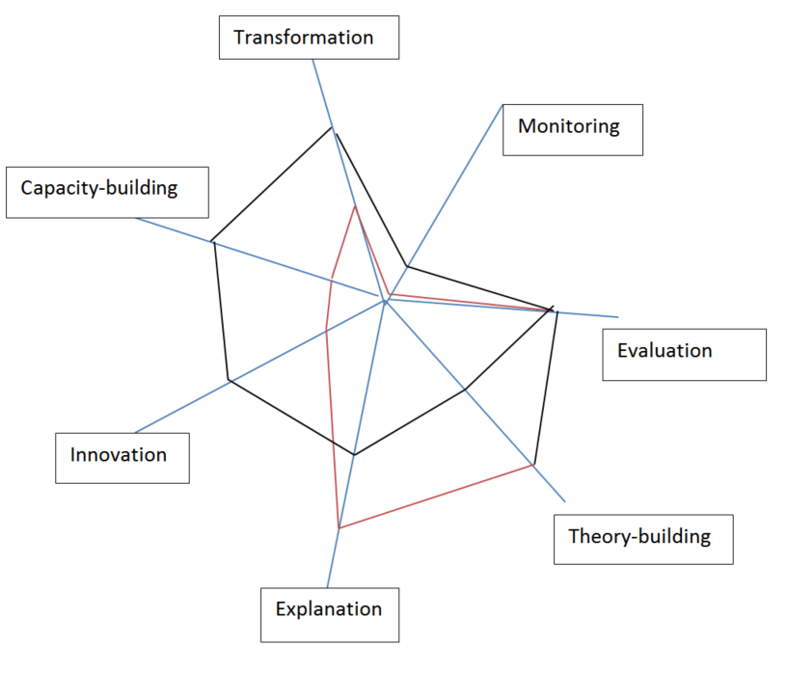  C) What are the goals of the project?  D) What are our key concepts?  Can we understand each others’ language, even if we use different terms? | Agreed purposes of the project.  - Identify common purposes  - Identify purposes more important to individual partners  Are there other stakeholders who need to agree the purposes?  - Colleagues  - Wider organization  - Client / donor  Language  - Understand each party’s preferred concepts without necessarily settling on a single common language
2. Audiences  Research can have multiple audiences and stakeholders. It is useful to think about engaging stakeholders and communicating the research at the design stage. | Questions to consider:  Who is the research for? (Segment your audiences)  For each audience:  - When should they be engaged? (early / ongoing / at conclusion?)  - How should they be engaged? (formal role, consultation, sent information, dissemination, action, etc)  - What kind of research design and evidence will be heard by and gain traction with the intended audiences? | Important audiences and implications for the research design  - Choices of research designs  - Consultation/communications process
3. Institutional resources  Agreeing on the resources available and the practical responsibilities of each partner sets the stage for realistic expectations on all sides. | What resources are to be committed by each partner.  What are the expected timescales?  What are the risks, and how might they be mitigated?  How will reviews of progress be undertaken?  What skills are required?  - Networking and brokering  - Facilitation  - Research design  - Academic knowledge  - Implementing research  - Strategic understanding of context  - Communication | Resources to be committed by each partner  Timescales  Schedule and approach to reviewing  Division of labour (according to the skills required: who will do what?) [may need to come back to this after the discussion of the research design]
4. Evidence  The agreed research purposes and intended audiences set the stage for the research design, and selecting the kind of evidence most suited to achieving the project’s purposes. | - What research approach(es) and types of evidence will respond to the research purpose(s)? For example:  - Participatory action research  - Experimental evaluation design  - Quantitative data  - Qualitative formative and process-focused research  - Survey research on behaviours or opinions  - Interview or focus group study  - Case studies  - Participant observation  - Mixed methods  - What process of research analysis and reflection might be required and who needs to be involved?  - Does your organization have a preference for particular types of evidence and why?  Tool: Evidence flower.  The ‘evidence flower’ can be used to discuss partners’ preferences for types of evidence and research practices, and possible alternatives. The first circle of petals identifies particular research practices. The second circle identifies dominant framings of those practices, and the final circle identifies alternatives. Discussion of all of these allows the possibility of novelty, as well as responding to dominant expectations.  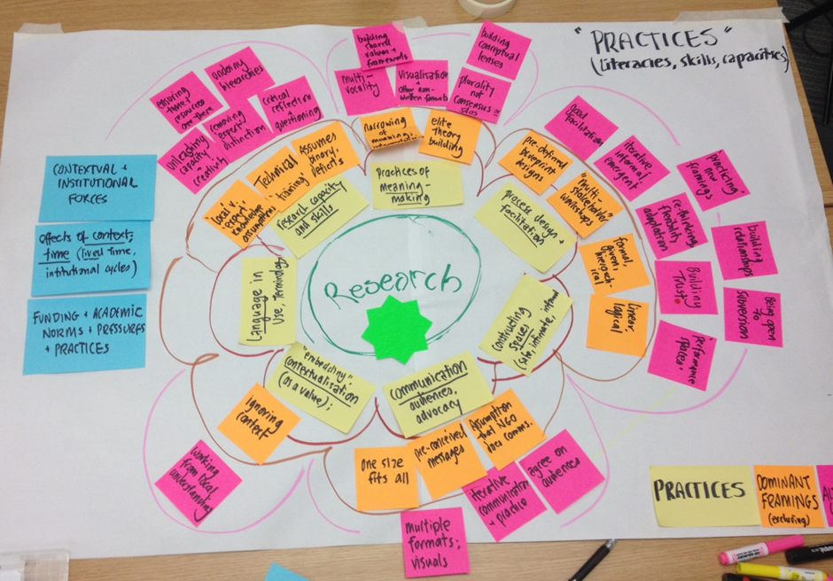 | Overall research design, and component parts  Check that the design allows the partnership to meet each of the identified purposes and goals, and the needs of each of its audiences  Which research methods contribute to achieving which purposes?

