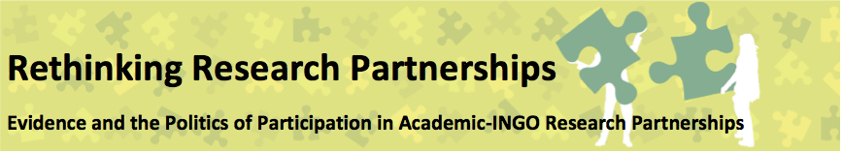

SEMINAR 2: ESTABLISHING AND SUSTAINING PARTNERSHIPS
28th April 2015: IPPF, London
SEMINAR REPORT

The first of the four ‘core seminars’ focused on establishing and sustaining partnerships. We started the day by reconnecting with the partnership case studies and developing ground rules. We then presented and analysed the first partnership case study, exploring issues specific to the case and then using it as a springboard for wider discussions shaped by other partnership experiences and our analytical framework (see below). We finished the day by discussing the implications for the rest of the series.

1. Introductions and Ground Rules

The day began with a series of ice-breakers to re-introduce participants and their partnerships.

We introduced ourselves and each gave an example of a piece of evidence we had found significant. This varied from examples of a particularly powerful story or film, to thoughts about how multiple types of evidence complement or contradict each other in particular contexts, to ideas that challenge the very basis on which we approach particular types of evidence – for example the writings of Antonio Damasio on ‘Descartes’ Error’ where he argues that rational study needs subjective and intuitive engagement to make it make sense. The breath and range of discussions helped us to relocate ourselves within the discussions on the politics of evidence.

These individual introductions were followed by a participatory exercise where we were invited to position ourselves on a spectrum according to different aspects of our partnerships. These included: the size of partnership funding; the number of partners involved; the duration of the partnership; and the level of ‘harmony’ within the partnership at different stages. For each aspect, a selection participants were asked to reflect on where they had positioned themselves. The exercise demonstrated the many differences between the partnerships we’ve experienced and are discussing in the series, and the different challenges and opportunities that each aspect of partnership presents. It reminded us of the importance of context in thinking through the individual case studies.

We then divided ourselves into smaller groups in order to think through the types of ground rules we thought would be important to ensure good participation, engagement and analysis in these closed sessions. Box 1 outlines the ground rules we developed.

Ground Rules for the Core Seminars

- PEOPLE AND WHO WE ARE REPRESENTING: Being aware that the people in the room speaking about the partnership are not representing every perspective of their organisation – there may be others involved in the partnership who are not in the room, and we need to be clear and honest about whose voice we are representing.
- CREATING A CRITICAL AND PARTICIPATORY ENVIRONMENT: It is helpful if we have continuity of participation in the seminar, although we recognise that is not always possible. We should all make an effort to participate and engage, to be open and honest, experiment and try out new things and be reflexive, to provide the best possible environment for participation. We should engage critically about power dynamics and be constructive in this; and we should share openly and honestly so that we can learn from mistakes
- BEING CLEAR ABOUT THE STATUS OF INFORMATION: we need to take time to agree which issues can be blogged, written up, kept confidential. We agreed the principle of Chatham House Rules (neither the identification nor the affiliation of the organisation can be used in public documentation). We agreed that we should only tweet after an event, not during, and that any documentation that could be sensitive should be signed off by participants before being shared more publicly.
- PROTECTING THE BROADER PARTNERSHIP RELATIONSHIP: the interaction between partners in this space, and the partnership more generally is important. Some critical issues may be raised which have not been discussed between partners yet. This space should be a suspension of the partnership so that we can critically reflect on the partnership; but equally it will be important to ‘not drop bombs’ – it is for each partner to take the time to discuss issues before the seminars so that there are no major surprises in the group sessions. Equally it will be important to protect confidentiality between participants and the wider institutions, so that on-going institutional relationships are not affected by specific discussions raised here. (Could there be a reflection at the end on the effect these discussion have had on the partnerships?)
- STRIKE A BALANCE BETWEEN PROCESS AND OUTCOME: We need to ensure that on the one hand we have a useful protected space for openness and sharing, with a deliberate attention on the ultimate goals of the series – to provide materials to strengthen partnership practice.
2. The First Partnership Case Study

The academic and INGO partners in the first case study had worked together ahead of the workshop to produce a detailed background paper on their partnership, which was disseminated ahead of the workshop. This background paper, which was structured to respond to our emerging analytical framework provided a rich introduction to the partnership. Through a joint presentation, and by using a visualisation of the history of the project in the form of a river (see Image below), the academic and INGO partner reflected on their experience. Key insights are shared below. The focus of the presentation was on the theme of ‘establishing and sustaining partnerships’ – which meant that more focus was put on relationships and process, with less attention on the types of evidence produced, or the impact of this evidence.

In order to protect the confidentiality of the partners involved we have limited the details included, but the following gives a broad description of the partnership:

It was a large-scale funded research partnership ($15m over 5 years) involving 1 academic and 2 INGO partners. One of the INGOs managed the funding contract, one of the INGOs was active in data collection, but the research was entirely designed and managed by the research partner. The institutional relationships between the academic and INGO partners pre-dated the funding opportunity that formally launched the partnership.

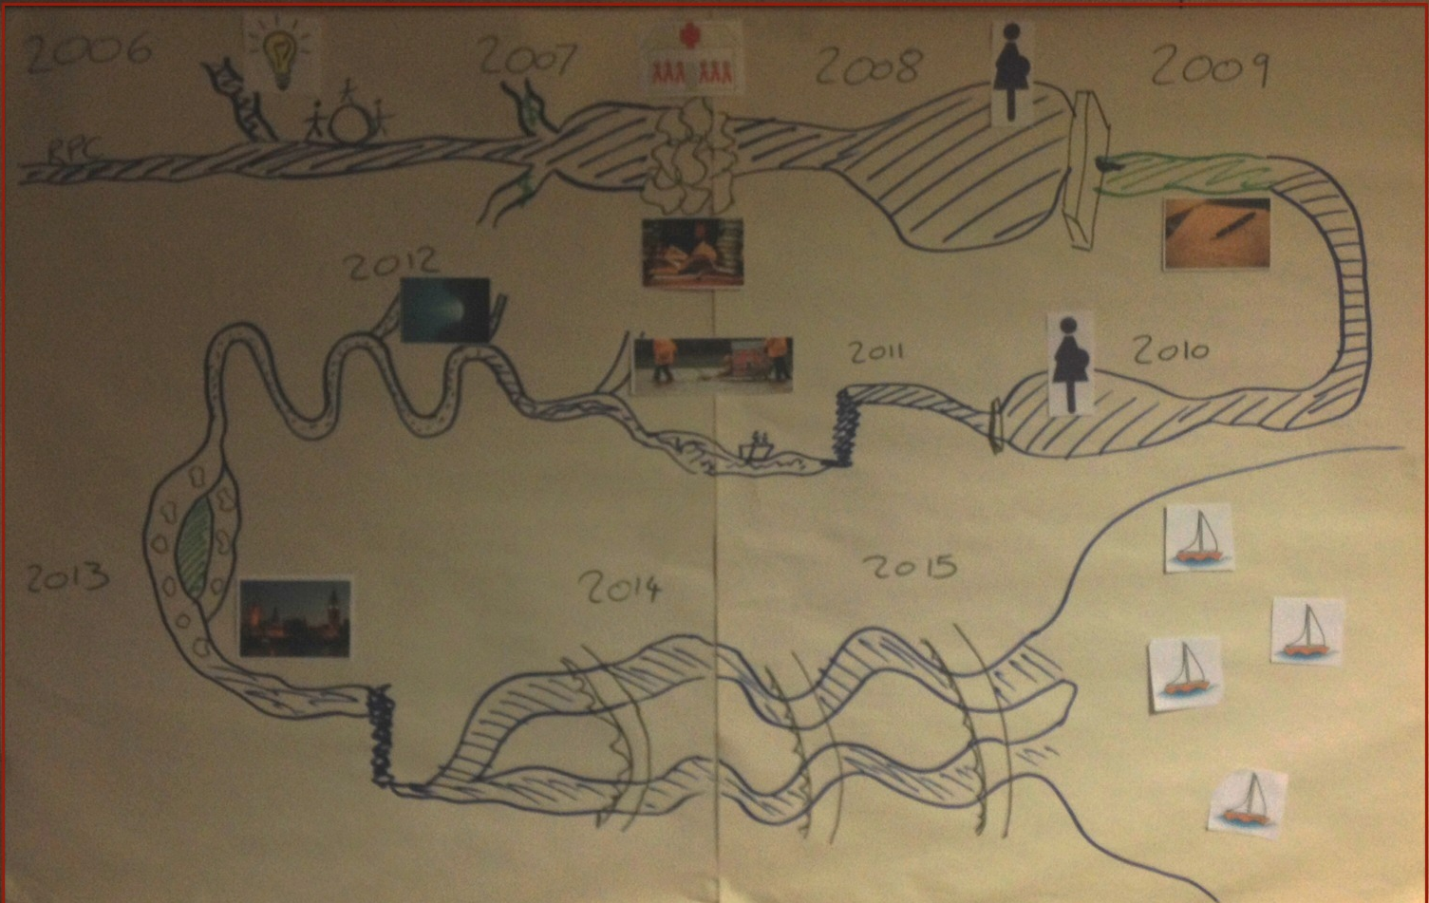

- The Early Years:

- Partners already had a longstanding relationship and so the conversation about the work started as a conversation between friends and there was a strong mutual sense of purpose. The principle partner was the INGO who brought the academic partner into the project to take full responsibility for the research strand.
- Despite initial consensus, an early challenge concerned how the funding was divided and exposed different priorities (‘saving lives’ directly through service delivery versus research into how best to save lives). Ultimately, the INGO ‘won’ because of their role as the grant-holder (although the split of funding was still largely in favour of research – with $9m on the research side and $6m on the service delivery). This meant that the research protocol had to be adapted, and led to the decisions to reduce the number of countries involved (from 3 to 2 countries).
Key insights from the case study:

- It is easier to get agreement between partners when developing the funding application, than when you have secured the money and are allocating ‘real’ money, rather than just ideas. It is at this point that real decisions needs to be made and tensions can emerge.
- Although individual relationships can be crucially important for partnerships to work, shifting personal can also open up new opportunities, and help in moving through tensions
- The way the different institutions ‘owned’ the research differed: While the INGO saw the research as owned by the whole organisation (with ensuing commitment at senior level to support the initiative); the academic institution offered little institutional or administrative support to the process, which rested on the shoulders of the individual researcher.
- The size of the funding meant that the partnership was too big to fail, this led to both partners investing effort in making the partnership work. Equally important was the recognition that when the institutional partnership was going well, individual relationships worked better, so there is an important interaction between individual and institutional relationships

- Staff changes and personal:

- Delays in administration on the academic side were a major problem. Although the funds included money for administrative and financial support, it is not customary in academic institutions to resource specific research projects in this way – so the university involved did not recruited or allocate dedicated admin and finance staff. This lead to severe delays in reporting and implementation which jeopardised funding – though was partly resolved when a formal letter was sent by senior staff from the INGO to senior staff in the university.
- Although the initial partnership was based on personal relationships and mutual knowledge and respect, changes in INGO staff actually helped in resolving the early tensions in the project. This was also the case when the academic Principle Investigator (PI) moved faculties, as in the new faculty proper finance admin support was given, thus reinforcing the importance of individuals and context in these partnerships.
- A major issue was the academic PI’s maternity leave, which is again indicative of the different institutional contexts and the way research is often conceived/owned within academic institutions. Although the PI did try to delegate her workload during her leave (and in principle, had a co-investigator committed to the project) little happened during her absence, perhaps due to insufficient institutional cover, and there were severe delays. The second maternity leave was less disruptive due to more effective delegation.

- Analysis and communication:

- Slow receipt of data from the field and problems with the data (due to misunderstandings by the third partner responsible for data collection on the ground) led to delays in analysis and interpretation towards intended end of the project.
- There was a tension towards the end of the partnership as the INGO and donor needed results to meet a deadline for a large public event planned in the Houses of Parliament, while the academic partner did not want to release data until all analysis was complete. In the end a compromise was made, with preliminary results released with the caveat that they were subject to change.
- Although the academic partner was concerned about the early release of results, in reality the dissemination event was very useful in terms of heightened recognition of the value of the project in the eyes of the academic institution

- End of project and the future:

- There was a further staff change within the INGO just two months before the anticipated end of the project. However, in some ways this was helpful in terms of pushing all partners to think about the end of the project and the next steps.
- There was another ‘parting of ways’ between the INGO and the university reflective of initial dichotomy (saving lives vs best way to save lives) but both partners were granted additional funds by the donor on an individual basis to continue the analysis and promote results. Though the partnerships funding had finished there was ongoing collaboration in terms of dissemination. The partners also maintained communications so that new opportunities for partnerships can be explored.

Meaning of evidence:
There was an interesting dynamic and understanding between the two partners on the nature and meaning of evidence.

Initially, the academic partner felt very compromised by the pressure to release preliminary data for the event at the Houses of Parliament. There was concern about its accuracy, and also how this might compromise future publishability. And yet, the event itself was useful in terms of raising the profile of the academic institution and highlighting the ‘impact’ of the research. The INGO was able to coordinate a much higher profile public event than the university would have been able to.

In addition, the academic was impressed with how the INGO translated the complex nuanced academic findings into concise user-friendly policy briefs – which managed to get the key messages across.

The range of dissemination activities by the INGO convinced the academic partner that this was not purely an academic project but that it was important to get messages out and change practice. This all happened alongside a simultaneous shift in academia with an increased emphasis on demonstrating impact (as part of Research Excellency Framework - REF), so the dissemination events became increasingly valuable to the academic PI, and her institution. Parallel to this was the increasing demand for evidence in the INGO itself, and more broadly in the sector. In this way, the partnership also opened opportunities for reassessing the meaning of evidence and academic collaborations as well as for future funding streams.

Group discussion

The group discussion was wide and varied, and probably could have continued for the rest of the day if we had allowed it to! In addition to the issues already noted above, the focus of discussion included:

- The size of the funding involved, and therefore how high the stakes were to make the partnership work. Yet even though large amounts of money were involved, the same tensions emerged surrounding priorities, high institutional overheads for the academic partner, and low priority/investment in admin or finance support. What is the role of academics and universities to challenge the lack of provision for admin support, how can different types of partnership help in this?
- The donor in this particular case study was very hands off, and only interested in good project management and implementation to schedule. This has benefits and challenges – sometimes donor involvement can be useful as a intermediary when things get stuck.
- Communication, dissemination and research uptake were not discussed at the onset – and yet this was a key point of tension. Could the issues of research communication have been discussed earlier on in the partnership – or would this have been even more problematic, given that they would have been quite abstract at that point in time? How much should be discussed at the beginning, how much can be pre-empted, and how much needs to be dealt with as it emerges?
- The challenge of integrating research and service delivery – does this make these partnerships more complex and likely to experience tension, or does it provide a richer incentive on both sides for collaboration? Should we categorise partnerships differently – i.e. some aimed at changing practice and some are focused on understanding practice? And what does this mean for ‘evidence’?
- How each institution used and exerted power within the relationship – the INGO held the purse strings, so had the power in that way, but the research was managed by the university on the basis of their ‘research expertise’ and ‘capacity’, so there was a mutual dependency but different types of power. Moreover, the individuals in the partnership experienced power differently within their own institutions: the academic was relatively powerless in her initial faculty, and needed the INGO input/exertion of funding power to ensure that the project was able to start at all (the INGO staff wrote to the university management regarding their concerns about lack of administrative and project support to the researcher).
- The space and ability to resolve relationship issues and differences in opinions about the project focus, timings, ultimate aims (to save lives or to research how best to save lives) played out in different ways and different times, and when the deadline was closer (e.g. with the event at the houses of parliament) there was greater pressure to resolve differences – and this actually made compromise easier.
- Could the INGO have had more input into the research without stepping on toes? In this particular case there was an issue of capacity within the INGO: the organization had taken the decision not to build their own research capacity, but to partner with others to be able to do research. This resulted in very limited engagement by the INGO in research design, especially at the earliest stages. The second NGO project officer was a PhD student, and was more engaged, though this could also have been due to timing with more available data, and in fact she was deliberately recruited by the NGO because of her research experience. But the research was generally very ‘academic’ in its conception – it did not try to build with/from NGOs experience of research (a point discussed in detail below).
- The two different types of organizations have different stakes in the data and research – e.g. academics are less interested in the results themselves, but they do need clean results and intellectual property, while for INGOs the interest in key findings, and the implications for changing service delivery is crucial. In this way, although the INGO did not participate in research design, the staff did participate more in interpretation, analysis and messaging.
- The fact that the nature of evidence is shifting in the academic sector is interesting – there is an increasing interest within the whole higher education system on non-academic evidence and therefore as the NGO outputs were produced they became of more interest to the university – who could claim research impact.
- Although the research period has finished there are ongoing discussions between the partners – how to present the right content to the right audiences. Important in this has been the training of national and local journalists in the countries where the research took place on reporting /use of good evidence around the research.

In the break before lunch we asked all participants to reflect quietly on their own – and draw a picture, think of an image or metaphor, write a piece of prose, or even a poem which identified some key issues, insights, reflections of questions which emerged to them through listening to the case study. This reflective piece was not shared, but the intention is that participants will return to it, and elaborate it further over the course of the next 3 seminars, as a way of capturing their learning and reflections through the process. This will contribute to the final outputs of the seminar series. We also hoped that by spending a short time reflecting individually, participants would be able to engage more critically and deeply in the afternoon session, where we were to consider the case study further and draw out implications for establishing and maintaining partnerships.

3. Analysing the Case Study
(Implications for establishing and maintaining partnerships)

The afternoon session enabled participants to step back from the immediate detail of the case study, reflect on their own partnership experiences and consider these jointly to deepen our understanding of how partnerships can be established and maintained. We divided into three groups with each group focusing their analysis on one part of our emerging framework.

- Group 1: Explored insights related to the Type of Partnership, reflecting on questions about the different context and purposes of partnerships and attempting to understand why certain principles work in some contexts and not others.

- Group 2: Explored participation in partnerships, and how this impacts on the types of evidence produced and valued, under the heading of Power within partnership. They focused on producing a matrix of the different partners involved, the different stages of the partnership and the different power dimensions which were important.

- Group 3: Discussed Power through partnerships, reflecting on how these partnerships can be agents of change - within individuals, institutions and broader society.
Types of Partnership
Questions & ideas for participatory tools of analysis:

- What were the purposes of the partnership and who controlled these different agendas? How did these influence the ways in which the partnership was established and sustained?

- Venn Diagram (illustrate the relative power of different purposes and relationships between them through circles of different sizes/ proximity)
- Flow Diagram (exploring purposes and their influence on process or purposes and their influence on the partnership as system)

- Identify the different ways in which the partnership was established and sustained. Identify the different ‘context variables’ that contributed to the ways the partnership was established/sustained. How might this have been differently affected by different contexts?

- Matrix relating context variables to the different components of establishing and sustaining partnerships

- What ‘type’ of partnership is the one in this case study? How might this be represented

- Come up with one or more metaphor, symbol, logo etc. to summarise the partnership (or aspects of the partnership) as a ‘type’ of partnership

One purpose of session was to use the framework developed in the first seminar, to evaluate out its relevance and application. A further aim was to trial some of the tools (see boxes) developed to critique the case studies. These tools were designed to provoke further critical reflection and discussion, to enable the group to engage directly with the experience that had been shared in the morning – but also to situate the practical experience of analysis within a more academic framework.

Group 1: Types of Partnership
Discussion points included:

1. In this particular case study there was a complete division of labour – between the INGO which held the purse-strings and was accountable to the donor for the money, and the academic institution who designed, managed and analysed the research. The dichotomy was established early on – around the question of ‘saving lives’ or researching ‘how to best save lives’; and this difference in approach/ultimate vision appeared to be more or less sustained throughout the partnership. There was little space for co-production or joint voice in this partnership. The group felt that it was important that partnerships acknowledged and recognised what the division of labour was – noting that in many partnerships this will not be as extreme as in the one explored in this seminar.
Was the dichotomy presented in this case study a narrative, or is this an exaggeration of INGO versus academic. Are we building stereotypes that already exist, and falling into a meta-narrative?

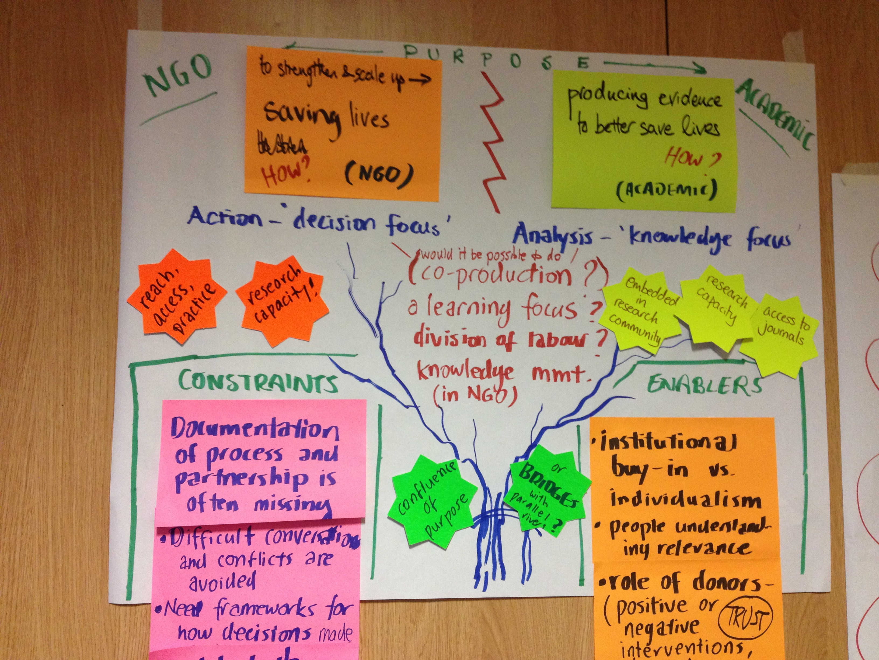2. There is a spectrum of different types of partnerships. And it can be helpful to brand the partnership itself – to give it its own identity beyond the institutions it involves – so that its purpose can exist beyond these institutions. This could be helpful when having those difficult conversations, about exactly how the money is divided, and where the priorities are. This could make discussions around the division of labour, and the rationale for valuing all contributions to the partnership for what they are more straightforward. Sometimes we opt for fuzzy agreement to avoid conflict, but hard conversations need to happen at some point and earlier is better.

3. The interaction between the individual and their institution is very different for the academics and INGO practitioners. For academics, the research is very dependent on the researcher, and if s/he is not there (e.g. on maternity leave) there is little institutional knowledge or apparent commitment to continue the research. This is not the case for INGOs. Individuals are so important – and can overcome institutional issues - who is at the helm at each partner agency also makes a huge difference.
Part of the temptation of partnering with smaller organisations – think tanks rather than universities is that there may be less power imbalances. Does this make genuine partnerships easier if smaller organisations are involved? Does the size of the players matter?

4. How the partnership is formed is important – there was prestige for the NGO in partnering with a well-respected university, more prestige than if they had recruited and implemented the research themselves. But the process of selecting partner was not clearly developed – it was more about who you know than a clear understanding of who the best partner might be.

The role of the donor in these partnerships is really important. For this particular example the donor was very hands off and that was OK, but it would be helpful to have more engagement of donor, to be clearer about their expectations of the role of research, the type of action and impact expected. Donors are frequently pushing these types of partnership, wanting the ‘academic rigour’ but lack of clarity of what is expected and wanted in practice. The donor can often wield power silently – with the NGO (or academic) believing that they know what the donor expects, even without the donor saying this explicitly – the NGO might internalize this, and fear the donor – work to please the donor, without necessarily being completely clear as to what the donor is expecting
Reflections on the context variables: In this partnership there was a pre-existing relationship, how this is nourished impacts on how the partnership evolves. Another context issue which was relevant was the location – both members of the partnership were based in London – this enables dialogue in ways that wouldn’t be possible had the geography been different, Some universities work directly with Southern-based NGOs and bypassing northern organizations. There are considerations around who drives the partnership – do the contextual factors drive NGOs towards universities or vice versa, - is it the universities that want to bring in NGO partners, for ‘impact’ or is it that the NGO has a big grant and brings the university in, for ‘evidence’. ‘Overheads’ and the way these are framed and understood in the different institutions were highly relevant – with the university partner not investing in administrative support in the way the NGO partner did, or the way they were expected to in the partnership – this is a common issue in universities, where admin costs are not generally considered properly in research partnerships. There are other models to do research – with small independent research institutes, or partner with think tank. It is important to think about the purpose of the partnership to decide what sort of institution might be most appropriate.

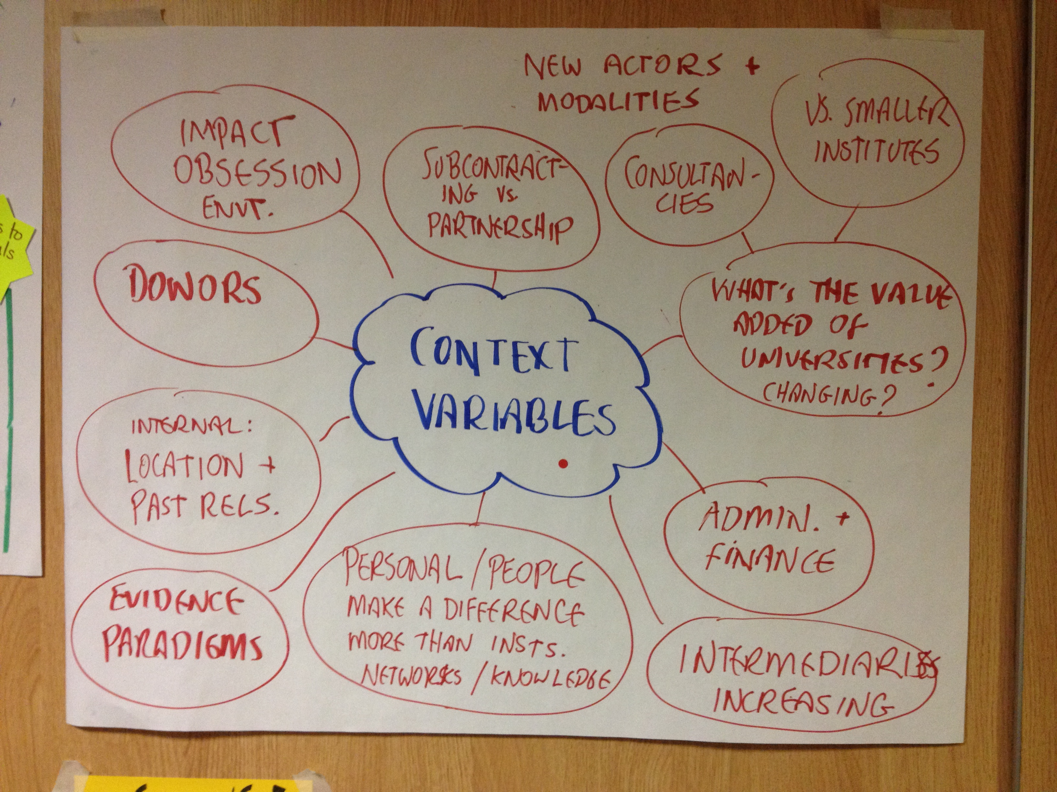
Spider diagram illustrating the ‘context variables’ which contribute to how the partnership is established and maintained
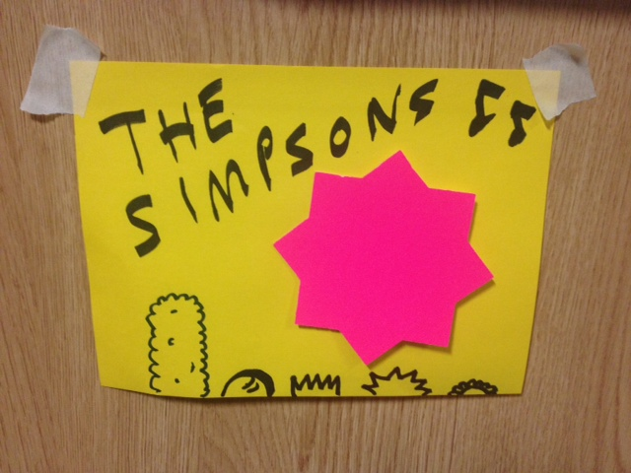
Finally, the group discussed metaphors for different ‘types’ of partnership. In the case study, there was a sense of alliance but also a lack of discussion at virtually every stage – or avoidance of talking about the real issues. It was like a dysfunctional family (e.g. ‘the Simpsons’)
Group 2: Power within Partnership
Group 2: Power in Partnerships
Questions and tools for analysis
The aim of this analysis is to contribute to our understanding of the different factors that influence how different actors participate in partnerships and the types of evidence that are valued in and produced through partnerships as a result.
1. Who participated at each stage of the process/in each activity and how?
* Develop a participation time-line/matrix of activities (if possible including nature and extent of participation by different actors)
2. How was that participation configured by institutions, practices, artefacts, narratives?
* Code each instance of exclusion according to whether this was due to conditions set by institutions, research practices, research artefacts or narratives
3. What types of evidence were valued/produced as a result? Were there any other types of evidence that might have been incorporated but were excluded?
* Evidence tree/ cause and effect diagram

The group started by brainstorming the different actors involved in the partnership case study presented earlier. Four institutions were identified and within each, a number of different actors/roles/locations.

In thinking through power and participation, the group had to decide whether they would concentrate on tracing: i) how different actors were involved in key stages/activities over the course of the partnership; or more specifically ii) who made the key decisions at key stages/activities over the course of the partnership. Ultimately, the group decided to focus on decision-making as a marker of power/participation.

After identifying the actors, the group brainstormed the key stages/events/ activities within the partnership. Interestingly, these ‘elements were not necessarily chronological but often recurring at different points in the process with different actors taking key decisions at different times.

To complete the matrix, the group ranked actors with decision-making power at each stage from 1-5 (with 1 indicating the most powerful.) To illustrate how power was channelled, the group also flagged whether the decision-making capability was based on institutional structures/processes, practices, artefacts or narratives. The participant who was representing the INGO in the actual partnership pointed out that the matrix might have looked very different if the academic partner – or even the third unrepresented partner – had been in the group instead.
The academic partner was depicted as particularly ‘powerful’ in this discussion – that they were not present for. It is unlikely that they would have considered themselves as such. This could be definied as a ‘narrative’ issue – how do partnerships represent themselves, and whose voices are included/excluded in that representation?

The group also recognised that even within decision-making, there were (at least) two types of power at play: enabling and restricting. In terms of the visualisation tool, the group did not get to the point of integrating those different types of influence.

Finally, the group contemplated the influence of the different sources of power on the way evidence was treated in and produced through the partnerships. Interestingly, it emerged that a whole additional stream of evidence (based on evaluations of the service-delivery/advocacy aspects of the project) had been omitted from the case study because it wasn’t considered to be a part of the research focus of the partnership – another example of the power of narratives in partnerships (but with implications for institutions, practices and artefacts as well.)

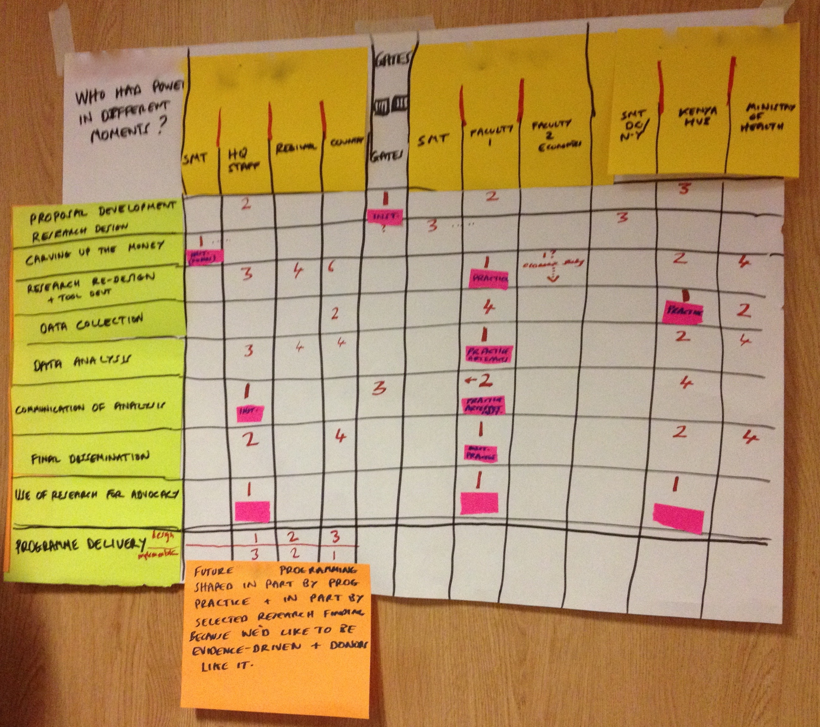

This photo show the matrix analysis of who had power at different stages of the partnership – the first column represents the NGO, the second the university and the third the implementing partner in the countries where the research took place. The higher the number the more power. (SMT= senior management team). The group discussed power in terms of who shaped the work, how the money was carved up, when the research was actually designed, analysed and disseminated, and how it was used in advocacy terms. They felt that the funder had most power at proposal development stage, but the NGO had greater power when budgets were being decided as they held the relationship with the funder. The research itself was controlled by the academic, but in terms of dissemination and advocacy – the ‘use’ of the research, this was more equally shared between the partners.

A pivotal question was identified for the NGO- What is more important in terms of their future programme development – was it their own learning and monitoring of the service delivery element of the work, or the academic research? The NGO wanted to be evidence driven and donors like it, but the non-research dimension had evaluation component- and there was an evidence collection here that was not categorized as research, or connected to the research itself – this had equal impact in terms of informing practice but no impact on the research evidence. The academic institution was not even aware that the monitoring and evaluation was happening alongside service delivery.

Based on the analysis of the partnership the group reflected further on the nature of power in the partnership, considering the relationship between power and the division of labour in the partnership – the matrix itself did not explore various dimensions of power such as positional power, gender etc. It was clear that each stage influenced the next stage, and there was an evolving relationship throughout the project – so that each stage was not so discrete from the next. The power analysis here was more focused at an institutional level – and their relationship, rather than the individual wielding of active power. They asked, to what extent would the results of the power analysis be predictable in advance? In such a large project no one really know what were getting into. Also the group did not spend so much time thinking about how power actually influenced the type of evidence produced, it would be interesting to discuss this further.
What does the fact that the NGO collected monitoring and evaluation data, which was completely separate from the research tell in terms of a. the relationship between research and M&E; and b. how we classify and understand evidence?

Group 3: Power through Partnerships:

The group really struggled with the topic, and did not manage to use any of the suggested tools properly – while there was a good and interesting discussion there were also many challenges surfaced around the conception and understanding of power through partnerships. At a very basic level we got a bit confused as to whether we were thinking about change in the world – is my intervention making a difference, or change in how research is done and conceived, or change in the actual partnership, and the relationships between the university and the NGO. There is also the wider question of can I understand and recognize the complexity of how change is happening and how to contribute to that?
Power through Partnerships

Questions and tools to help us understand the transformative potential of partnerships. How can ‘good practice’ in partnerships affect change in institutions, research practices, research artefacts or narratives?

- Identify examples of ‘good practice’ and/or learning from the case study (incorporating similar examples from other participants’ experience)

Brainstorming/story-telling

- How did (or could) these examples contribute to changing institutions, practices, artefacts and/or narratives?

Cause and effect diagrams/matrix

- What didn’t change and might there have been other ways of affecting change – or are certain transformations blocked by certain obstacles (and if so, what?)

Analysis of power/influence of different actors at different levels

It was clear that the nature of the partnership in this instance did not lend itself to transformation – of either institution, of the nature of research and evidence, or in relation to the roles and distribution of labour in partnership. The academic institution was commissioned to do the research, the NGO did not have ownership of the research – it only project managed it, so there was no co-production. At the other end of the spectrum you have academics and NGOs working together on participatory/action-oriented research – which has a different transformatory conception and potential.

Where things had changed – for example in that the university became more interested in the research, and included the NGO publications as part of a broader collection of research materials to show impact in response to the Research Excellency Framework – this could only really be understood as happening alongside the research partnership, rather than directly influenced by the partnership itself. It was more that there was a new use for the research in terms of furthering the universities submission to the REF – almost like marketing. Reflection on this led to a broader discussion around the nature of change – ‘things change, we are part of it, how do we know how things change and what role we play?’. However, there was a concrete change through the partnership – in terms of NGO - academic partnership began to be perceived as more legitimate. There was a better recognition that NGOs can show impact

We identified barriers to achieving change: firstly there was a question (and a potential disagreement in the group) as to what research is for – is it to create change, to see if change is needed? Do we start with a hypothesis and investigate, or start with a theory of change, and expectations of change? Sometimes you start a piece of research with a very clear idea of the change you’d like to see, and sometimes this only emerges through the project itself. Questions also included, how does research influence wider world? ‘there is the rhetoric of evidence based practice but does research really influence in this process?’. There were also issues such as the how incentives are structured for academic career progression, what behaviours are valued (ie is team work collaboration valued in academia, how are outputs conceived and understood) and the influence this has on the transformative potential of partnerships.

We explored the difference in research for programming (to improve programme practice/service delivery) and research for policy change – which might respond to a particular political context, moment and opportunity. These types of research have very different objectives and suggest that the partnerships in each case will have very different dynamics; as is the type of evidence produced – for example a participatory approach might not be taken seriously (as ‘rigorous) in policy focused research, and how research has contributed to change is potentially even more difficult to identify.

For academics there is often less of an emphasis on change through the research, and the likelihood is that they would be happier waiting until the end of a piece of research before producing outputs, or disseminating findings. The NGO on the other hand, is doing the research because of wanting to see some sort of change – and this led to an interest in sharing the outputs earlier in the process. But then what sort of outputs lead to change – publishing articles might help in an individuals career progression, but does it change anything? What do more ‘NGO type outputs’ achieve in terms of change? It is not evidence in and of itself that brings about change – we need to do something with it – it may be a necessary part of a change process, but it is not sufficient.

A final observation is that it is difficult to change institutions if you are one individual, although we saw examples of how pressure was exerted through the partnership – in terms of how the university resourced the partnership, in terms of how and when outputs were shared etc. – this does not automatically lead to change beyond the partnership which is influenced by a mixture of many factors; which led us to return to the issue of our different understandings about how change happens – and the relationship between research and change.
4. Wrapping up and links to the rest of the series

The final session focused on three issues: firstly, how we were going to document and share the seminar we’d just completed; secondly whether and how the tools, framework and process had worked; and thirdly how to ensure connection between this seminar and the next one in October.

- This report is one of the outputs from the first core seminar. There are also a series of blogs that will be posted on the website – we will also post a blog on the BOND website and share the work with them.

- Everyone enjoyed the use of the river – both the presenters as a tool to reflect on their partnership, and the rest of the participants, in order to understand and engage with the partnership. It was useful to read the in-depth case study first, then see the visualisation of the river to enrich it. The case study was more descriptive, while the river encouraged analysis, helping presenters and participants to identify key issues, and recognise their importance (such as the maternity leave) which hadn’t necessarily been foregrounded in the background paper.

Other analytical tools and aspects of the framework were found to be less helpful. In particular, the group focusing on transformation (or ‘power through partnerships’) found the breadth of the issue too difficult to address – with numerous possible avenues of analysis. They wondered whether such ‘really big questions’ might be too big for us as a seminar series. Does it make sense to focus on how to change how we actually work in partnerships rather than to change what is going on in the world outside partnerships (i.e. focus on our research practice)?

A related discussion focused on ‘Theories of Change’: How do different kinds of research and research partnerships build on different kinds of change – and the theories that drive them? Could taking a systematic view of the roles of different actors and the dynamics between them help us understand the value of different contributions to research? Participants also asked whether we are looking at ‘how research organisations partner’ or how ‘organisations partner for research’ – this distinction has implications for understanding the purpose of partnerships and how they are understood by different actors and institutions.

- Everyone was asked to keep hold of the reflection which they did in the break before lunch, and to add to this any thoughts over the next few months. All participants will be expected to update this reflection in the next seminar.

Beyond the plans for the next seminar there was also a feeling among the group that we needed to do a deeper collective analysis of power and political economy of these types of partnerships. Jethro will think through ideas of how to do this, and potentially convene a working group with Chick, Martin, Helen, Shelly and Kate.

The next seminar will take place on Tuesday 20th October 2015, at ActionAid offices in London.

